EDSC 458: Classroom Management
12/1/2017

Stefan’s Classroom Management Plan

By: Stefan M. Johnson

Table of Contents
Introduction………………………………………………………………………...3
Preparation Before School Begins………………………………………………....4
Procedures and Rules………………………………………………………………5
Classroom Safety & Discipline…………...……………………………………......7
Planning Instruction………………………………………………………………...8
Collaborating and Communicating…………………………………………………9
Cultural and Community Resources……………………………………………….
Summary…………………………………………………………………………….
Citations……………………………………………………………………………..

1. Introduction
Classroom management is about creating a plan for your classroom so that students have positive behavior reinforcement, safety, and the opportunity to learn. Successfully managing the classroom is more than just having strict rules. It is about involving your students in your process and teaching them your expectations (apa.org).
Teachers need to be a positive force in the classroom. If we can connect with our students it is possible to create a smoothly operating classroom. Teachers should be prepared to talk to both their students and parents in order to ensure your students are learning in the way that best suits them. (edutopia.org). The teacher must make it their responsibility to engage the student in class so that no one is left behind. A good classroom management strategy is one that ensures no student is left behind.
When in charge of a classroom your own presence is part of management. How you treat others and organize your classroom will be a model for your students to follow. You have to be a good role model by recognizing fault and being prepared. Invest yourself in the classroom but don’t be overly emotional, be prepared to show your students how to face conflict and how to compromise. Classrooms are places where students not only learn the required curriculum but also important social behaviors. (NEA.org)
Safety in the classroom plays a huge part in learning, as teachers be ready to talk to all your students about to handle issues inside and outside the classroom. Don’t punish your kids collectively, personally target students, or enforce harsh punishments (weareteachers.com). Your students should feel like they can talk to you about why they are struggling or incidents, so you can design your requirements accordingly. As stated previously, the success of your classroom hinges on understanding your students.
I believe safety, understanding, and positive behavior reinforcement is crucial to running a classroom. I want my students to know that they can talk to me and be a positive force in their lifetime to ensure they are successful after their secondary education. This CM plan will demonstrate how I intend to achieve this.

2. Preparation Before School Begins
- Arrange classroom in the way most effective for your instructional method
- Call home or send out emails to establish relationships with parents
- Purchase extra materials which you and your students may need throughout the year
- Decorate your room tastefully with educational and comfortable items
- Familiarize yourself with student names and talk to previous teachers
- Learn about popular activities in the school
- Prepare an introductory assignment to familiarize yourself with students
- Have a working syllabus for your students (so they know what to expect)
- Read over school handbook to sculpt your classroom accordingly (if new to the school)
- Learn names of students within two weeks, knowing names is the foundation of getting to know your students
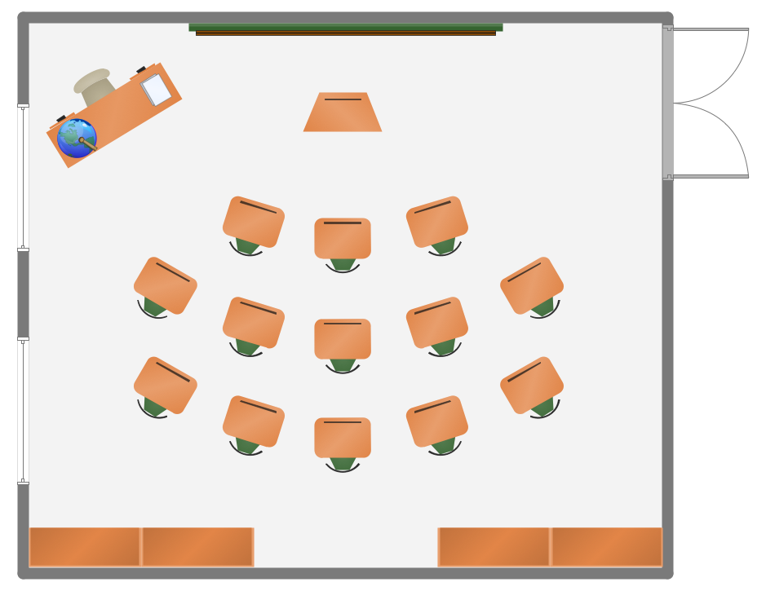
Figure 1: Auditorium Classroom Layout
3. Procedures and Rules
Rules & Policies:
- First rule, treat others as you would like to be treated
- Allow students to engage in the rule making process by writing out class expectations with them
- Allow time for students to discuss behavior and rules
- No assigned seats unless it is decided to be needed
- Raise hands for questions, no talking during a lecture unless called upon
- Give feedback to your students so they know how they are doing
- Late work is accepted, be prepared to talk to the teacher why it is late
- Bullying and disrespect is never tolerated, if you are a problem there will be steps taken (after-class meeting, being sent out of the room, a call home and other punishment if necessary)
- Most behavior issues will be addressed individually after class (do not single students out), if problems persist reach out to parents to understand if there are measures needing to be taken
Routines
- Hand out quick quizzes on previous material that offer several points
- Pass back any homework while students are occupied
- Take attendance quietly and check if students are missed by calling their name
- Students will be asked to reflect on their lesson of the day by writing down questions they have on a paper and turning them in
- Before students leave they will be asked to clean up their desk by cleaning up any trash in their area
- Teacher is to post homework on white board so students are reminded before they leave
Transitions, Interruptions & Materials
- Late students quietly enter the room, deliver a pass and are seated
- Passes (unless abused) can be taken quietly when needed
- Students will only clean-up when the teacher finishes the material (the bell doesn’t end class)
- Choose a student who is responsible to lead students to other areas (library, computer lab)
- Students are expected to have materials to learn, but some extra items will be stored in the classroom (books, paper, pens)
- Treat school property with respect, anything a student uses will be put away
- If necessary specific guidelines will be made for classroom materials
Group work & Activities
- Groups will be assigned by the teacher
- Be calm and understanding with group members
- All groups will choose a presenter/leader for their group
Management at the School Level
- Ensure behavior is within the guidelines of FERPA
- Establish a working understanding of how the school makes decisions to ensure your input is considered
- Avoid gossips about students, discuss students only if needed
- Know teachers around the school to avoid professional conflict
- Hold professionalism in high regard, behave professionally towards teachers around students
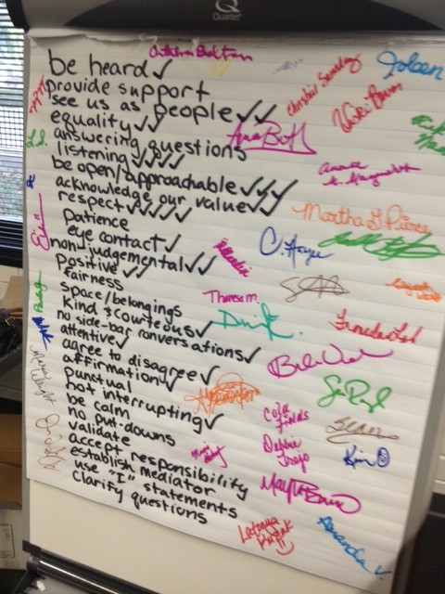
Figure 2: Example of Class Made Social Contract
4. Classroom Safety & Discipline
- Teacher will utilize pregnant pauses and eye contact to correct small inappropriate behavior
- Affirmation to students who are doing well to encourage good behavior
- Students who are failing to meet expectations academically or behaviorally will meet with the teacher after class, measures to correct behavior will be discussed between teacher and student
- Students will only be sent out of the classroom in the most extreme situations
- Students will never be directly singled out in the classroom
- Safety information will be displayed in the classroom for fire and other emergencies
- Handouts including the school’s policies on safety will be passed out at the start of the year and delivered to parents
- Criminal acts will be handled outside the classroom by school administration
- Any emergency drills will be carried out according to school policy, students are expected to behave responsibly during these instances, if a student does not follow procedure knowingly they will be disciplined by the administration

5. Planning Instruction
- All students will be treated fairly and positively
- Teacher will use conversation and surveys to get to know students in order to tailor lessons to be more applicable to students interests
- Instructor will always work towards being engaging for the entire class and understanding of student needs
- Teacher will treat students as individuals (using names, using break time to converse with students, talk to students early in class)
- Teacher will move around the room to guarantee that all students are getting the help they need
- Using affirmative vocabulary towards students even when they are wrong so that future participation is not discouraged
- Students will never be intentionally ignored
- The teacher will make eye contact with students and engage them as much as possible
- Teacher will talk to students before class if they are concerned about a problem arising
- Remain level headed and calm to preserve emotional objectivity
- Students are encouraged to talk to the teacher about problems if they are concerned about school or their own safety (the teacher should always be a safe person for students to turn to)
- The teacher will be a positive role model in the classroom and teach students about assertiveness and responsibility
- The instructor will constantly consider which students are having problems outside of class and be ready to deal with them appropriately
- Take care to set time for self, relax on off days and don’t get too stressed out
- Be sure to practice self-awareness and to understand your own emotions (disengage from situations that become too emotional for you)
- Do not burn out
- Remember that every student is different, there is no one style fits all

6. Collaborating and Communicating

