Got to love learning
A Classroom Management Plan for Secondary Education
By: alexandra Hurley
EDSC 458
2017

Table of Contents

Introduction………………………………………………………………………………………3

Classroom Management Plan

Preparation Before School Year Begins………………………………………………......5

Routines, Policy, Procedure, and Rules…………………………………………………...8

Safety and Legal Requirements………………………………………………………….10

Planning Instruction and Student Diversity (cultural and special needs)…………...…...10

Collaborating with Educational Stake Holders and Community Resources…………….12

Summary…………………………………………………………………………………13

Works Cited………………………………………………………………………...……15

Table of Contents for Figures

Figure 1……………………………………………………………………………………5

Figure 2……………………………………………………………………………………7

Introduction:
Having a plan, and sticking to it is what classroom management is all about. According to Clement (2010), “Without sufficient knowledge of classroom management strategies, new teachers may begin their careers striving to manage as they were managed.” If new teachers have no way to manage a classroom, they could fall into the trap of myths like, “start out mean, don’t smile before Christmas, and when all else fails, turn the lights on and off” (Clement, 2010). These are not the right way to deal with issues in the classroom, and having a good plan about how to deal with students acting out before they get the chance is an all-around better strategy.
Classroom management plans are essential to any classroom because they establish rules, procedures, and allow for routines in the classroom to form. Respect is one of the best things to expect and demand for a classroom’s success. Having every person in the room respect each other leads to a safe, happy classroom environment. Another vital piece of classroom management is routine. Lester, Allanson, and Notar (2017) say that, “By setting the tone of routines, the student information amount is broken down into chunking and a sense of freedom from anxiety or fear is experienced.” When students know exactly what to expect when they step into the classroom, the classroom can be considered managed effectively rather than disciplined ineffectively (Lester, Allanson, Notar, 2017).
Knowing that some students will act out no matter how great the plan is necessary. The teacher has to have a piece in their management plan that addresses discipline, and how it will be carried out. The students should know the way the discipline will go, be it a three strikes policy, a zero-tolerance policy, a call home, etc. Students that act out need to know what to expect, a teacher cannot just make up punishments as the students act out. To minimize interferences the discipline must be firm and consistent (Lester, Allanson, Notar, 2017). Putting consequences right into the rules in the very beginning of the year lets the students know exactly what will happen if they act out.
A huge part of having a classroom management plan is knowing when it is not exactly working. If a teacher is stuck in their ways, and blames the students instead of a faulty management plan the year is miserable for all involved. If an aspect of the classroom is not working properly, the best thing to do is look at everything. It may be one students causing trouble, but more than likely, it is a flaw in the classroom management plan.
For me, classroom management means that there is mutual respect form student to teacher. The students know exactly where they stand, they know the rules, the consequences, how to be prepared for class, and how to have fun when the time is right. It is very important to me that everyone feels safe enough to voice their opinion in the classroom. Since some of English classes are discussions about the literature, I want everyone to be able to actively participate in discussions.
I take a very humanist and behaviorist position while teaching. I will ask that my students do the best they can to keep a positive learning environment for everyone in the class. I know that I cannot ignore all the negative behavior, and I need to address it. I will have a very one on one approach with discipline. This fits into my classroom management plan because my rules and procedures will be very clear, and negative behavior will be addressed in a way that doesn’t make the student feel disrespected by me. My idea is to create a safe space with respect all around.

The Classroom Management Plan:
Preparation Before School Year Begins
My classroom will be decorated with posters that succinctly explain the parts of speech for English (see Figure 1). It will also have commonly misspelled words spelled correctly everywhere. Another great thing to have on the walls, or if I can on the ceiling, are all the forms of “your”, “you’re”, “there”, “their”, and “they’re”. These commonly made mistakes will be fixed on the posters, and hopefully staring at them all period every day will help my students to avoid making these mistakes in the future. I really want my classroom to have color, as well. The posters will have their own colors, so there won’t be an overwhelming color-bomb being dropped. The students still need to be able to concentrate without having their eyes hurt from too many colors all around them.
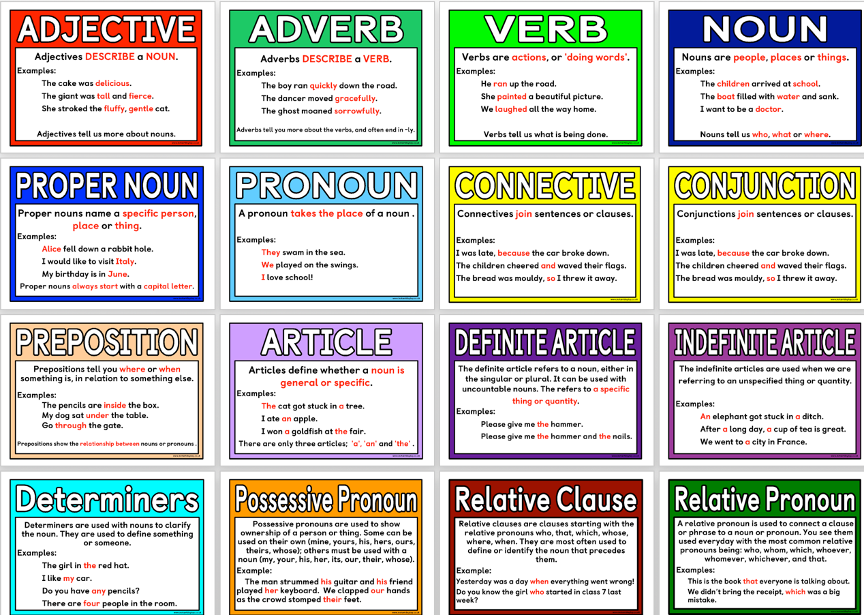
Figure 1 (parts of speech posters example)
I will have a drawer full of paper and a drawer full of pens right by my desk. This will help keep the students ready for anything I could want them to do. The students will write their name on a piece of paper next to the drawer if they take a pen, and I will call the names to get the pens back every day. I will also have a few paper dictionaries on hand, and a small library of books for students if they forget their book, or finish an assignment early in the back of the room. I will offer extra credit for students who bring in things like tissues and hand sanitizer. The desks will be arranged in a in rows of three facing the board with walkways (stadium seating), so small group work can be easily done, and the students also have space to work individually when the time comes for that, too. (see Figure 2) I will require the students to have a binder or folder to have in every class period. When they first walk in the door copies of the classroom rules will be on the desks, and they will put them in their folder or the front of their binder. I will also post the rules on the wall right by the door.
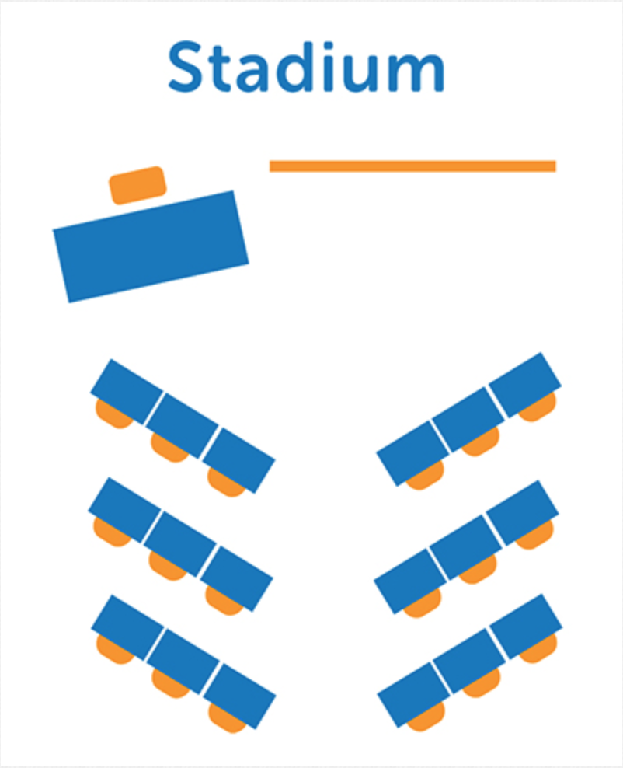
Figure 2 (seating example)
On the first day of school, I will greet every student at the door with the attendance sheet, and ask them their names and if they have any nicknames they prefer. This way I won’t embarrass any student by mispronouncing their name. I will let them choose their seats, and then I will record it so I can learn names. As soon as everyone is seated, we will start the ice-breaker activity. The students will introduce themselves and tell the class their current favorite book or movie. After this, I explain the rules they have on the desk in front of them, and I show them where the rules are posted by the door. I will hand out and go over the syllabus for the year, then have the students discuss the syllabus, and finally have the students ask their questions about it. The syllabus will have the daily procedures in it, so the students can refer to that to know what to bring to class every single day, and what we will be doing in the first ten to fifteen minutes. We will start every day with a “sponge activity” (Marzano, et al. 2005), it will always have something to do with the lesson plan for that day, or possibly even helpful tips for an extended project.
Over the first two weeks I will build relationships with the students so that they know they are safe in my classroom when they come in every day. I will greet them every day after the “sponge activity” (Marzano, et al. 2005), and we will discuss the plans for the day. This is the routine that I will work to cement within the first two weeks of school. I will also cement the homework policies over the first two weeks, I will take late work for half a letter grade off every day that it is late. If the school doesn’t give out planners to students, I would recommend that they get one within the first two weeks. One of my mentor teachers had a wall where the students could display their good work, and I would like to have a wall like that as well. This will make the students feel special because they get to see their good work on the wall when they come into class.
Routines, Policy, Procedure, and Rules
There are a few rules that I will be very stringent about. Respecting everyone on the classroom is most definitely one of them. Another is, there will be no phones, unless it is a designated time to be on your phone. I will embrace technology for learning purposes in my classroom. There will be days where it is part of the lesson plan to find a website for class that the student thinks is a good source to learn from. The consequence for having phones out when it is not a designated time is I take it, without disrupting the whole class, and the student gets it back at the end of the period. If it happens more than once it becomes the whole day, and then the phone goes to the principal.
I will not be one of the teachers who calls out students behaving improperly. There is usually a reason the student is acting out, and I think that an individual conference with the student is better than shaming them in front of all of their peers. If I can help the student with their problem or mood that is making them act out in class, then I will. Although, if the behavior continues, and I cannot help, the student will be sent to either the counselor or the principal.
Group work is going to be a part of my classroom because talking about literature, or reading their essays to each other helps the students process what is happening in the literature, and it helps them find mistakes to fix in their essays. Peer-reviewing is another procedure that my students will know well. They will read, and give their ideas on each other’s essays. There will definitely be independent seat work though, too. The students will read alone, and do free-writes on what they have read alone to get ideas for discussion flowing.
At the beginning of class each day the students will sit down and do what is written on the board, it will have something to do with the lesson that is being taught that day. The transition will be from the sponge activity to the first lesson of the day. The pregnant pause (Marzano, et al. 2005) will come in handy for this transition until the it becomes routine to go from sponge activity to the daily plans. On days where we use technology I will have the students create a single file line to grab their assigned number computer or tablet to work with, in this instance my procedure will be to raise my hand and make eye contact until they settle into the line to get the supplies they need.
At the end of the day the students will normally just be able to pack up their things and leave the room to go to their next class. On the rare occasion that class will go over the bell, I will let the students know that when the bell rings they are to stay put until I dismiss them to go on to their next class.
In my room, the schoolwide rules will go right next to the classroom rules and procedures by the door. These will also be explained on the first day, I want the students to know exactly where they stand. The emergency evacuation or code red information will go right on the door. At the beginning of each semester I will decide who leads us out in case of a fire, and who locks the door, closes the blinds, and turns off the lights in a code red lockdown.
As for staff interactions, I will not gossip, and I will do my absolute best to be a team player in making decisions for the school or the students. What is best for the students is the right decision, and we all need to be able to work together to find what is best for the students and be firm on that decision together.
Safety and Legal Requirements
I am going to do my part, and follow the school’s discipline codes for big things like fighting, etc. I am going to follow the discipline hierarchy, and make sure that the students know I am not going to be swayed on following the policies set by the school. The students will also know exactly what to do in case of a fire, or a code red lockdown because we will practice in the first two weeks of school on our own as a class.
Planning Instruction
Maintaining strong student teacher relationships is important in my classroom if I want the students to respect me, and if they want me to respect them. Going to sports games to support the school and the students, making sure the students know that they can come talk to me about anything. I will give them full disclosure that I might have to tell the counselor, but I still want to be able to help any way that I can. Asking how everyone’s day is going, finding out what the students are interested in so maybe I can make a project for them to do with their interests, all while still keeping in mind and letting students know that I am still the teacher, not a friend.
Working with the students on their own development is important, too. They need to understand what responsibility is, and how being responsible works both in school and in the real world. Taking responsibility for forgetting the binder they are supposed to bring to class every day is something that can teach them that they need to be more self-sufficient. This could relate to accidentally forgetting an important piece of a project at work, the boss isn’t going to care the employee forgot, they just want the employee to take responsibility and fix the issue.
For big projects (not essays), I am going to give my students freedom to do whatever interest them as long as they fulfill the requirements on the handout I give them. This will allow for differentiation in learning without me having to give each student a project handout that I think they will do well on because the medium interests them. Sometimes with essays or readings, I will not be able to use differentiated learning, but when I can use it I will. It keeps students interested because they get to learn and do something they enjoy to make a project.
For students with special needs and Individual Education Plans (IEP), I will make sure to keep in communication with their guardians, and if they have them, their companions at school. Keeping in contact with guardians is important regularly, but with a student with special needs it is a necessity to keep the guardians apprised of what is happening in school, and what the student is supposed to be working on at home.
There are also students who come from different cultures and have different customs in school, or do not participate in some aspects of celebrations because it is not celebrated in their culture. It is important to me not to single these students out, they can leave the room quietly and go to the library, or another place in the school where they can peacefully get work done. If other students ask about why the one student leaves when we celebrate a holiday or maybe even a birthday, I will tell them to respectfully ask the student. It is not my place to tell anyone about that student’s culture, they can respond to the questions if they choose to.
Keeping emotional objectivity with students is going to be difficult sometimes, and I know it. I will just have to remind myself I need to keep the negative thoughts out of my head, and I need to think of something positive. I will also have to work on being able to keep a cool exterior, no one needs to know if I am having trouble liking a student.
To keep myself from getting burned out teaching and doing all the paperwork that comes with it, I will do things I love to do. I love to swim, read, and watch movies, all of these activities will help me stay fit and help me to release stress I might have from teaching. Sometimes taking a dance break from grading papers is all I need, too. I am just going to have as much fun as I can teaching, and take the some time to do things I enjoy between the teaching an the paperwork.
Collaborating with Educational Stake Holders and Community Resources
Keeping open lines of communication with parents and administration is vital to me because the parents have to respect me as a teacher to be able to teach their children. If they come to me, or email me, with questions I will get back to them as fast as I can with the best answer I can give. if the parents want to schedule a mini-conference with me, or I want to schedule one with them, to discuss their child I will come prepared, and ready to discuss their child’s grades and progress. If I need to contact parents for disciplinary reasons for their child, I will make sure they know I don’t think badly of their child because the child got into some trouble. Another thing I can do is inform parents of all the opportunities the students have to see how English is used even more than students think it is. There are so many ways to use language to express so many different things, like, poetry, plays, newspapers, news on TV (someone had to write the prompts for the anchors to use), and even in cultural performances language is used. I can let parents know about all of the extra credit opportunities I will be offering to sudents who go to these events, and can tell me how language was used in them.
Five resources I can use in the community are:
- Theater performances of plays like Shakespeare’s
- Public librarian as a guest speaker
- Guest speakers with careers dealing with the English language (copy editor for newspaper, journalist, if possible a local author, etc.)
- Field trip to a playhouse/theater to see how they work, and maybe do a skit on the stage
- Giving extra credit for going to local art galleries or local cultural performances
Summary:
I believe that my classroom management plan will work well for me in the future, but I am willing to make changes as I have not taught high school yet. When I start to teach I will most definitely enforce the rule of respect, and do everything in my power to make my classroom a safe environment for every student who enters into it. I will use this plan as a guide to make my rules off of, and as a guide to stay away from burning out.
I will form my plan more solidly when I begin to teach, and see how students react to my plans of classroom management. There isn’t really a way to tell if this plan will hold up yet. When I do begin to teach, and I meet my students who I will get to know, and see how they work, and how my plans of, sort of, differentiated learning play out. I am excited to put this plan into practice to see if it works soon.

WORKS CITED

Clement, M. C. (2010). Preparing Teacher for Classroom Management: The Teacher Educator's Role. Delta Kappa Gamma Bulletin, 77(1), 41-44.

Ediger, M. (2009). Seven Criteria for an Effective Classroom Environment. College Student Journal, 43(4), 1370-1372.

Forseid, M. C., Forseid, M. P., Gaddy, B.B., Marzano, J.S., Marzano, R. J. (2005). A handbook for classroom management that works. Alexandria, VA: Association for Supervision and Curriculum Development.

John Hattie, a., & Helen Timperley, a. (2007). The Power of Feedback. Review Of Educational Research, (1), 81.

Lester, R. R., Allanson, P. B., & Notar, C. E. (2017). Routines are the foundation of classroom management. Education, (4), 398.

Montrieux, H., Vanderlinde, R., Schellens, T., & De Marez, L. (2015). Teaching and Learning with Mobile Technology: A Qualitative Explorative Study about the Introduction of Tablet Devices in Secondary Education. Plos ONE, (12), doi:10.1371/journal.pone.0144008

PHOTO CREDITS

Displays2go.com. (2017). Effective Classroom Seating Arrangements. [online] Available at: http://www.displays2go.com/Article/Effective-Classroom-Seating-Arrangements-32 [Accessed 1 Dec. 2017].

Instantdisplay.co.uk. (2017). Literacy Resources for Writing, Many free sets of posters, games and other printables. [online] Available at: http://www.instantdisplay.co.uk/writing.htm [Accessed 1 Dec. 2017].

