**Classroom Management Plan for my Secondary Classroom**

Joshua Vann

EDSC 658

December 12, 2017

**Table of Contents**

**Introduction…………………………………………………………………………………………...…...2**

**Before the Year……………………………………………………………………………………………4**

**Rules & Procedures……………………………………………………………………………………….4**

**Managing Work Styles……………………………………………………………………………………6**

**Safety & Legal Requirements………………………………………………………………………….…7**

**Discipline……………………………………………………………………………………………….…..7**

**Interpersonal Connections…………………………………………………………………………..……9**

**Being a Good Role Model…………………………………………………………………………..……11**

**Responsibility & Self Betterment………………………………………………………………….……12**

**Community Resources & Contingency…………………………………………………………………13**

**Conclusion: Classroom Management and My Future………………………………………….…..…15**

**References. ………………………………………………………………………………………….…...15**

**Introduction**

Effective learning takes place when students feel safe and are willing to take academic risks. In order to facilitate this type of learning, a comprehensive classroom management plan that benefits all students is needed. An classroom management strategy can look very different depending on the philosophy and mentality of the teacher, however in essence the same underlying principles will persist. The most important part of a classroom management plan is that it creates the environment in which your students will learn best. In order to do this effectively, one must know their personal style and be able to adapt to the style of the students.

By knowing what is important to oneself as a teacher, and getting a feel for what is important to the students, it is possible to create an environment where everyone’s needs are respected and an environment meant for learning (Frymier & Houser, 2000). This begins by shaping the structure of rules in the classroom, however rules are not enough. Classroom management goes much deeper than this. Rules are a good jumping off point, but it is important that these rules be shaped into productive measures that the students actually respect (McGinnis, Frederick & Edwards, 1996). All in all, classroom management can take many different forms, but at the heart is caring for the students, structured learning, and ability to react and adapt in positive ways (E. T. Emmer).

Having the students take responsibility in the classroom is one of the most effective methods for maintaining control of the classroom: students that take responsibility for their learning manage themselves. In fact, students themselves used to be accountable, however a recent study showed that recent apathy, absenteeism, and grade inflation all contribute to a slowly emerging lack of accountability (Hassel & Lourey, 2005). Leading to this, students are reported to feel that teachers react to misbehavior with their use of coercive discipline, which ends up having the opposite effect. By increasing their use of discussion, rewards, and involvement of the students in decision-making, teachers can increase student responsibility (Lewis, 2001). Studies also suggest that other methods to increase student accountability are explicit expectations, smaller classes, absenteeism consequences, grading consistency, elimination of the extra credit model, and reorganizing responsibility for retention and enrollment (Hassel & Lourey, 2005). At times, it may even be beneficial to have the students create problems for test and truly take responsibility for their learning (Cunningham 2004).

Most importantly, it is important to not only care about the students, but to show this care as well. Studies have shown that for at risk students, showing that you care can actually help more than the best teaching. If students know that their teacher believes in them and cares, they will be motivated and have more success (Muller 2001). Unfortunately, the opposite is also true. In a study looking at the viewpoint of the excluded students, what is found is that the student ends up having an idealized view of what the relationship is or should be; which ends up having a detrimental effect on learning (Pomeroy, 1999).

The hardest part of classroom management is separating one’s own personal belief set from teaching. One of the hardest subjects to do this with is Math, especially if one is not explicitly a math teacher. There are many different methods for dealing with this interplay, however if one is able to discard the personal belief set it is the most useful method (Ernest 1989). Unfortunately, when teachers are constantly discarding their belief set, it can lead to negative self-motivation. The biggest problem with this is that it can lead to burnout. A study of teachers in the Netherlands showed that negative attitudes toward implementing new instructional practices led to higher rates of burnout, while higher self-efficacy believes regarding implementation of the practices and positive stress management techniques led to lower rates (Evers, Brouwers, & Tomic, 2002). There are many other strategies to avoid burning out, and many involve positive self-understanding as well as self-regulation. As mentioned previously, teachers must know themselves in order to be effective in the classroom (Martinez, 1989).

Today, classroom management is much different than it has traditionally been. Not only does it vary across different areas of the US, but it varies between different subject areas as well. In my personal classroom, I will always try to keep the element of respect, in both ways, as one of the highest tenets of learning. In the modern classroom, it is important to differentiate and ensure that every student does his or her best. In the new age classroom, it is difficult but still possible to create a learning environment that supports differentiation while maintaining rules and procedures for the classroom (Tomlinson, 2014). In my classroom, the students will have responsibility for their own learning, and my management plan will revolve around maintaining respect and open communication about learning difficulties and issues that arise. I know that every student has the potential to succeed, and it is important to me that they believe this too.

In the following sections, I will summarize aspects of Classroom Management, and will use the following as a loose adaptive plan over the course of my future career as a teacher.

**Before the Year**

**Preparation before the School Year**

* Classroom Setup is important
* Decorate in your own style, but with cultural integrity in mind
* Development of lessons
* Policies Posted
* Learn names as early as you can
* Reach out to parents (email/letter)
* Talk to previous teachers

**Management at the School Level**

* Familiarize yourself with school policies
* Introduce oneself to Principle and Vice-Principle
* Meet other teachers

**Rules and Procedures**

**General Classroom Behavior**

* Do unto others as you would have them do unto you
* Establish rules early on, either by making them together or by posting them at the beginning
* Write a class pledge or promise
  + Have class help write the pledge
  + Have all students sign the pledge
* Reinforce norms consistently
* Post rules in a visible place
* Rules should be succinct and not too many
  + Respect, politeness, and consideration
* Seating
  + Lower Level – Assigned
  + Higher Level – Free to choose as long as its not disruptive
* Graphics around the classroom can be useful
  + Honesty, integrity, respect
* Some examples of simple rules are:
  + Raised hand (To signal to be quiet)
  + Hands over ears (if too noisy)
  + Raised book or pencil (if there is a question during quiet time)
* Model the procedure for students, or ask for help from students modeling good behavior
* Provide time to talk or write about why rules and procedures are important
* Provide feedback to students about how they are doing following rules and how they can improve

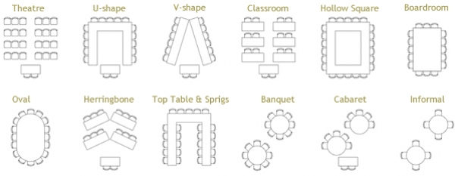

Figure 1: Different Classroom Setups

**Beginning and Ending a Period or Day**

* Begin and end consistently each day
* Begin with a balance of learning and administrivia (attendance, announcements, etc)
* Establish unity through shared activities
* Use sponge activities as daily warmups
* Establish a sense of community
  + Pledge of Allegiance
  + Birthdays
* Ending class
  + HW assignments
  + Reflecting on learning
  + Answering questions
  + Remind students to put away supplies
  + Reflection writing activity

**Transitions and Interruptions**

* There are many possible interruptions to learning that can happen during the day
* Establish rules and procedures for reoccurring situations
  + Bathroom pass
  + Completing activities early
  + Leaving for lunch
* Practice transitions and potential interruptions
  + Practice routines, such as fire drills and bell ringing
  + Role playing is a useful method of practicing routines
  + Be in seats ‘before’ bell rings
  + What happens if late? procedure well outlined
* Engage students as leaders during transitions and interruptions
  + Student volunteers as line leaders
  + Leading lunch breaks
  + ‘Student leader’ a role of responsibility
  + Give students ‘important’ tasks
* “Five minutes left”

**Use of Materials and Equipment**

* Establish rules and procedures for common classroom materials and equipment
  + Set simple rules, like:
    - Treat the things we share with care
    - Keep common areas clean and neat
  + Rules for how books and resources are distributed, stored, and collected
  + Take care of desks
  + Use of other items, like pencil sharpener
  + Borrowing rules (Borrowing shelf)
* Establish rules and procedures for specialty materials and equipment
  + Specialty materials include computers or globes, printer scales, or science material
  + Set rules for these materials which make sense and promote positive uses and respect of the materials
  + Safety first
  + Ask for student contributions to the rules to promote leadership and community

**Managing Work Styles**

**Group Work**

* Group work is good, but in order to be great it is necessary to establish guidelines early on
* Establish rules and procedures for moving into and out of groups
  + Signal for moving into groups
  + Establish rules for transition, like ‘push in your chairs’
  + Establish groups so that everyone knows where to go and who they are going to be working with
  + Seating arrangements can support group work
* Setting expectations for group behavior and focus
  + Write objectives for behavior
  + Give feedback
  + Set objectives with students, individual or in group
  + Self assessments are useful tools
  + Make sure students are clear about the purpose of working in groups
  + Work on leadership skills “Leader for the day”

**Seat Work and Teacher-Led Activities**

* Set expectations for students working in their seats
  + Noise minimized
  + Create a list of activities to do once students have completed their work
  + Create a library or fun activity to do as a reward once work is finished
    - Opportunity to read
    - Writing station
    - Research and investigation opportunity
* Maintain students attention during teacher led activities
  + Quick polls (thumbs up/thumbs down)
  + Countdown and call outs (cue for attention, or calling out of a student to be quiet)
  + Random drawing (dice!)
  + Student assistants
    - Involvement of one student at a time

**Safety and Legal Requirements**

* Know the safety rules and procedures in place at your school/ school district
* Make sure students know where to find this information, and have access to it in the classroom
* Fire/intruder safety: Teacher and Students must know the protocol and practice drills
* Lab safety: Have a lab safety contract and quiz
* Make sure fire extinguisher is handy, vents, gas and sinks well maintained and managed
* Make sure stockroom is well kept and chemical safety well known

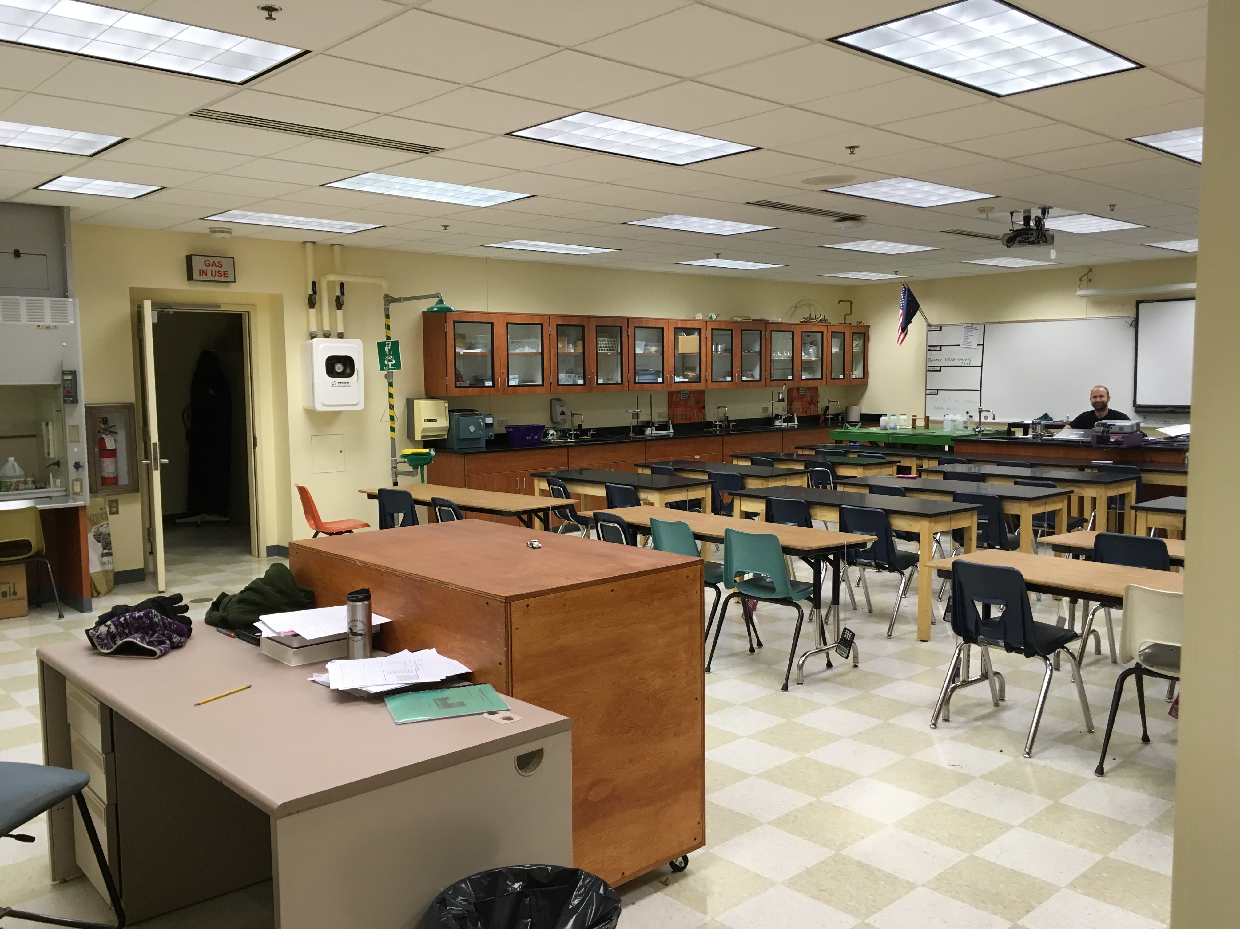

*Figure 2: Mr. Hansen’s Classroom*

**Discipline**

**Teacher Reaction**

* Reactions that address inappropriate behavior
  + Verbal and physical (nonverbal) reactions
    - Verbal more useful at secondary level
  + Look at the student and say the name, or ask short question (‘What’s going on?')
  + Pregnant pause: An awkward silence created to make the offender uncomfortable
    - Careful, this can lose the attention of the group
  + Move to the front of the room and stop instruction
  + Eye contact
  + Subtle Gestures
  + Heading Students off before the class: “What kind of day will we have today?”
    - Followed by nonverbal cues
* Reactions that reinforce appropriate behavior
  + Short Verbal affirmation
  + Smiles, winks, or other signals
  + Catch Students being good

**Strategies for Conflict Prevention and Resolution**

* Developing a written statement of shared beliefs
  + We are responsible for ourselves
  + We are responsible for how we treat others
  + We have a part in how our peers and teachers treat us
  + We have a part in how our environment works
* Using Class meetings
  + Students often voice concerns of more than themselves
  + Class meetings help to strengthen:
    - Constructively voicing ideas and viewpoints
    - Thinking Creatively
    - Problem solving with others
    - Reflecting on one’s own behaviors and their effect on others
    - Responsibly communicating points of disagreement
    - Respectively discussing how others’ behaviors affect you
    - Respectfully and thoughtfully questioning others ideas
  + Over time, students should facilitate these meetings
* Teaching students specific strategies for conflict prevention and resolution
  + Misunderstandings arise easily and it is important to be able to deal with these conflicts effectively
  + Students need to be able to deal with their emotions, especially anger
  + Anger CAN be controlled
    - Most misunderstood and misused emotion
    - Can be understood
    - Recognize when you first become angry
    - Take a time out
    - Return to the situation

**Tangible Rewards**

* Extra Credit
* Work Days
* Verbal Praise and Critique
* Certificates
* Reward Field Trips

**Direct Cost**

* Secondary
  + Saturday School
  + Natural consequences
    - No credit for missed hw
    - Failing an exam means a lower grade
    - Poor grades means not going to college of choice
  + Time out, exclusion from class, and expulsion all remove disruptive students from their peers.

**Interpersonal Connections**

**Demonstrating Personal Interest in Students**

* Discovering and incorporating students’ personal interests into academics
  + Student interest surveys
  + Teacher-student conferences
  + Informal conversations with students
  + Taking notice of the kinds of activities that students participate in outside of school
  + Ask students things about themselves and to incorporate them into their learning
* Noticing individual accomplishments and important events in students’ lives
  + Use parent teacher conferences to learn about family events in student’s lives
  + Develop good relationships with other teachers to learn about students
  + Read the school newspaper, newsletter, and bulletins
  + Complement students on achievements in and out of school
* Interacting with students as individuals
  + Use student’s name and greet them
  + Use informal times to get to know the students and learn about other happenings, such as classes
  + Positive phone home
  + Talk to students

**Behaving Equitably and Responding Affirmatively to Questions**

* Physical gestures and movements
  + Eye Contact
  + Moving around the room
  + Looking and Listening
* Positive interaction strategies
  + Attribute ideas and comments to those who offered them
  + Encourage everyone’s participation
  + Provide appropriate wait time
* Affirmative reactions to incorrect responses
  + Don’t tell students that they should have known the answer
  + Don’t ignore a response
  + Avoid subjective comments about incorrect answers
  + Don’t allow negative comments from other students
  + Provide correctives
  + State the question that the incorrect response answered
  + Encourage collaboration
  + Restate the question
  + Give hints and clues
  + Let students opt out
  + Provide the answer and ask for elaboration
  + Acknowledge the student’s participation

**Exhibiting an Assertive Connection**

* Know the Five Communication Styles:
  + The Assertive Connector
    - Focused
    - Eye contact
    - Speaking and listening
    - Reflects speaker’s emotions
    - Tries to fully understand
    - Sends the message “I value our relationship and what you have to say”
  + The Apathetic Avoider
    - Ignores the other person’s presence
    - Pauses too long before replying or barely replies
    - Interrupts
    - Is distracted
    - Doesn’t listen or mirror
    - Avoids relationship with other person
    - Sends the message “I don’t want much of a relationship with you and will put in minimal effort
  + The Junior Therapist
    - Takes a one-up position
    - Talks for the other person
    - Tells how the other person should feel think or act
    - Talk about the other person rather than themselves
    - Criticizes
    - Analyzes instead of listens
    - Sends the message “I know you better than you know yourself. I know you better than I know myself”
  + The Bulldozer
    - Focuses on one topic
    - Dominates the conversation
    - Says the same thing over and over
    - Speaks too loud
    - Aggressive
    - Name calling
    - May use violence or intimidating gestures to suggest violence
    - Sends the message: I will do whatever it takes to get my way”
  + The Hider
    - Speaks softly
    - Uses incomplete sentences (talk a lot but says little)
    - Maybe, sort of, speech
    - Pulls away
    - Doesn’t respond and ‘hides out’ in groups
    - Appears afraid of being heard, criticized or confronted
    - Sends the message “I am afraid of you and don’t want you to know about me”

**Being Aware of the Needs of Different Types of Students**

* Passive Students
  + Fear of relationships
  + Fear of failure
* Aggressive Students
  + Aggressive-Hostile
  + Aggressive-oppositional
  + Aggressive-covert
* Attention Problems
* Students who are perfectionists
* Socially inept students

**Being a Good Role Model**

**Exhibiting “Withitness”**

* Most effective managers regularly monitor their classrooms and address even the possibility of misbehavior immediately
* Occupy the entire room
  + Physically/visually
  + Walk to all areas of the room
  + Walk up and down rows?
  + Eye contact
* Noticing potential problems
  + Avoiding potential problems can encourage students to misbehave
  + Many signals including: lack of engagement, looking and smiling, looking at a specific part of the room, smile or giggle when you walk to a particular area, noises in specific parts of room
* Using a series of graduated actions
  + Look at the suspected students
  + Move in the direction of the students
  + Address the students in question; try to keep the incident from escalating
  + Stop the class and let everyone know that an intervention is required
* Forecasting Problems
  + Think about the students in the class and what trouble may happen. Which are prone to misbehavior?
  + Pairs of students?
  + Put students in a good frame of mind.
  + Incidents outside of class?

**Exhibiting Emotional Objectivity**

* Recognize that you are an emotional being
  + Feelings and thoughts have little to do with reality and don’t relate to our actions
  + Reaction from past experiences and beliefs
  + Reminders of previous encounters are removed
  + Recognize your preconceptions
  + Attitude is hard to change, but behavior is easily changed
* Monitoring your thoughts and emotions
  + Mentally review the student in your class, noting your emotional reaction to each student
  + For those who arouse negative thoughts, try to figure out why
  + Try to link events to these interactions and get over it
* Reframing
  + Thinking about a student’s action in a way that is not offensive
  + Occurs unconsciously in everyday life, but do it consciously with students
  + Benefit of the doubt!
* Maintaining a cool exterior
  + Emotional objectivity must be displayed through behavior
  + Avoid extremes, especially anger
  + Avoid pointing your fingers, raising your voice, squinting, moving toward the student
  + Instead, speak calm and directly, look at the student, maintain appropriate distance, being conscious of your expression
  + Ok to state anger verbally, by saying why you are angry and using a calm and even tone of voice
  + Listen
* Taking care of yourself
  + There will always be the occasional negative interaction
  + Teacher’s problems are represented in interactions with students
  + Students notice stuff like that
  + Learn from mistakes, and forgive students and yourself
  + Start fresh each day
  + Controlled Breathing, guided imagery, funny movies, special treats, and maintain a healthy sense of humor
* Preventing and recuperating from burnout
  + Mental health scale.
  + Nonfunctional bad
  + Cant survive without the help of others.
  + Superior functioning
  + Dysfunctional levels
  + Average?
  + Emotionally healthy

**Responsibility and Self-betterment**

**The Nature of Responsibility**

* Helping students understand what responsibility is – and is not
  + Offer description of Personal Responsibility
  + Post something somewhere around the room about responsibility
  + Goal is to help them be responsible
  + Takes practice
  + Introduce terms to help them understand
  + Describe characters in stories or the news in both positive and negative situations
  + Brainstorm situations. “What would you do if…”
* Helping students understand the differences between facts and interpretations
  + Look at different situations where interpretation may differ from facts, such as in stories, news, and personal life
  + ‘calm the waters’
  + understand our own interpretations and biases
  + Be aware of negative interpretations
    - Tragic
    - Paranoid
    - Guilt-ridden
    - Blaming
  + Embrace positive interpretations
    - Funny
    - Practical
    - Enlightened

**Strategies for Personal Development**

* Helping students develop self-awareness
  + Be aware of thoughts, emotions, behaviors, and impact on others
  + Everyone experiences the same emotions
  + People express their emotions similarly as well
  + 6 basic emotions
  + avoiding eye contact is a sign of respect in some cultures
* Teaching students the strategy of positive self-talk
  + Our minds are the most powerful tools we have
  + Thoughts may or may not be useful
  + The optimist and pessimist go through the same struggles, but the optimist bounces back, while the pessimist gets floored
* Teaching students how to be assertive
  + Saying what you want without demanding
  + Behavior types include passive, passive-aggressive, aggressive, and assertive
  + Can come in different combinations and be different with different people
  + Can also be affected by different events
  + Discussion here is good
  + Possible to develop assertive behavior, by practicing and being self aware
  + Journal is a good tool to help develop and further student understanding

**Community Resources and Contingency**

The school is just one aspect of the life of the student. Social life, home life, and community interactions are all important parts of a student’s life and as a teacher it is important to integrate all these in a positive way. By being aware of the group contingency, a teacher has a better understanding of the students. By communicating and keeping a good rapport with the parents/home contingency, the teacher can create a positive environment of openness and any issues can be dealt with swiftly and effectively. By taking field trips to important community locations as well as culturally or academically important locations, it is possible to extend learning to beyond the classroom and show how important it is to be active in the community, looking at local businesses, museums, or volunteering in the community. By involving parents in these activities, it is possible to bridge the gap between home and the classroom.

**Group Contingency**

* Interdependent group contingency
  + Secondary Level
    - Group assignments using contingency for the grades (all get the same)
    - Recommend against the use of whole class contingency
      * Negative consequence for single who doesn’t perform
      * Lose equity

**Home Contingency**

* Making parents aware of their student’s behavior
  + Phone calls
  + Conference calls with parents and students
  + Parent-Teacher-Student Conferences
  + Orientation Packets
  + Parent Orientation packets
  + Notes to parents
* Establishing a system of consequences to be administered at home
  + Asking parents to take away privileges for specific disruptions if they continue
  + Encouragement of parents to work with you, not too much pressure

**Community Resources**

* Classroom Speakers
* Field Trips
  + Museums
  + Businesses
  + Factories
  + Music in the community
  + Volunteering
* Organizations and Support
  + Local Autism Societies
  + Learning Disability resources
  + Volunteer organizations
* Research Opportunities
  + University
  + Science Fairs

**Conclusion: CM in my Future**

The classroom management plan above is not a set list that I know I will follow to the dot. Instead, it is a compendium of different techniques that I will use as a guide. I personally believe that there is no amount of reading that one can do to prepare for classroom management. Instead, I believe that my understanding of Classroom Management will continue to change over the course of my teaching career. This plan instead will be a number of techniques that I can turn to if I am having trouble. Every class that I have will be different in some way and it is important to remember that all students learn differently and may learn best in different environments. By constantly reevaluating my effectiveness in the classroom and truly valuing what the students say, I can continue to grow as a teacher and eventually create an optimal learning environment for the students and for myself.

**References**

Cunningham, R. F. (2004). Problem posing: An opportunity for increasing student responsibility. *Mathematics and Computer Education*, *38*(1), 83.

Emmer, E. T. (1994). *Classroom management for secondary teachers*. Allyn & Bacon, A Division of Simon & Schuster, Inc., 160 Gould Street, Needham Heights, MA 02194..

Ernest, P. (1989). The impact of beliefs on the teaching of mathematics. *Mathematics teaching: The state of the art*, *249*, 254.

Evers, W. J., Brouwers, A., & Tomic, W. (2002). Burnout and self‐efficacy: A study on teachers' beliefs when implementing an innovative educational system in the Netherlands. *British Journal of Educational Psychology*, *72*(2), 227-243.

Forseid, M. C., Forseid, M. P., Gaddy, B.B., Marzano, J.S., Marzano, R. J. (2005). A handbook for classroom management that works. Alexandria, VA: Association for Supervision and Curriculum Development.

Frymier, A. B., & Houser, M. L. (2000). The teacher‐student relationship as an interpersonal relationship. *Communication education*, *49*(3), 207-219.

Hassel, H., & Lourey, J. (2005). The dea (r) th of student responsibility. *College Teaching*, *53*(1), 2-13.

Lewis, R. (2001). Classroom discipline and student responsibility:: The students’ view. *Teaching and teacher education*, *17*(3), 307-319.

Martinez, J. G. (1989). Cooling off before burning out. *Academic Therapy*, *24*(3), 271-284.

McGinnis, J. C., Frederick, B. P., & Edwards, R. (1995). Enhancing classroom management through proactive rules and procedures. *Psychology in the Schools*, *32*(3), 220-224.

Muller, C. (2001). The role of caring in the teacher‐student relationship for at‐risk students. *Sociological inquiry*, *71*(2), 241-255.

Pomeroy, E. (1999). The teacher-student relationship in secondary school: Insights from excluded students. *British journal of sociology of education*, *20*(4), 465-482.

https://tesolteacher83.files.wordpress.com/2016/02/seating-styles.jpg?w=680

Tomlinson, C. A. (2014). *The differentiated classroom: Responding to the needs of all learners*. Ascd.