CM Plan for the Secondary Science Classroom
Diana Marlowe
EDSC 658
November 30, 2017

Table of Contents

Title PAGE
Introduction 3
Before School Preparation 4
Rules and Routines 6
Safety and Legal Requirements 8
Student Engagement and Differentiation 11
Communication and Collaboration 13
Conclusion 15
References 16
Figures and Tables
Figure 1 4
Figure 2 5
Figure 3 5
Figure 4 6
Figure 5 6
Figure 6 7
Figure 7 9
Figure 8 10
Figure 9 11
Figure 10 13
Figure 11 13
Figure 12 14
Figure 13 14

Classroom Management Plan for the Secondary Science Classroom
Introduction
As a new teacher, there are so many things to learn, to prepare, and to focus on. Classroom management may seem like an extra item on the list that isn’t completely necessary. So, what is the purpose of classroom management, and why is it important to implement? In order to answer this question, let’s take a look at the research and get a perspective from veteran teachers.
Many teachers may have the misconception that classroom management is to “control student behavior.” Rather, it should be a means to enable better student learning. When the focus switches to creating a more engaging, safe, and comfortable learning environment instead of thinking of the best punishments and rewards to keep students in line, it becomes a more fluid, effective, and natural endeavor (Eisenmann, Edwards, & Cushman, 2015; Kwok, 2017). For example, instead of disrupting the entire class to deal with one student’s misbehavior, most of the time, the teacher can redirect the student with a content question, or utilize non-verbal means of communicating with the student while continuing to teach the rest of the class. This could be a look, the removal of an object, a head shake, or even pointing to a location for the student to relocate to. In this way, student learning continues, while inappropriate behavior is handled (Kwok, 2017).
Another important aspect of effective classroom management is student-teacher relationship. When students feel that they are important, that the teacher is going to actually benefit their life and has their best interest in mind, they are much more likely to participate and behave better in the classroom (Atici, 2007). When teachers maintain good interpersonal relationships, student motivation is higher, academic performance is better, and inappropriate behavior is at a minimum, creating a more positive classroom environment (Opdenakker, Maulana, & Brok, 2011).
Thirdly, when a classroom is well-managed, students feel physically and psychologically safe. Students need to understand that although there are rules and expectations, the teacher is there to help them and ultimately benefit them. When a student knows that he won’t get ridiculed for giving the wrong answer or ignored because he doesn’t read well, he can begin to relax and learn Deaton, 2013). Also, physical safety is important. If an individual is afraid of being bullied or hurt at school, she can’t focus on learning. The same is true for the teacher. If the teacher is being threatened or is afraid of violence in the classroom, he can’t do his job properly and is more likely to quit. When the school and classroom environment is authoritative (structured but supportive), instead of authoritarian or permissive there are fewer incidences of violence (Gregory, Cornell, & Fan, 2012). Rules must be in place, and they must be upheld by the teacher, but the students must also know that the teacher cares about them as well. This model increases student academic performance and motivation, while decreasing teacher burnout and inappropriate classroom disruptions (Gregory, Cornell, & Fan, 2012; Deaton, 2013).
- Classroom management focus should emphasize student learning instead of student control
- Teachers who maintain positive interpersonal relationships with students have better behavior and performance outcomes
- Good classroom management leads to a safe learning environment for students and teachers
Before School Preparation
First impressions matter, and in a classroom they set the tone for the rest of the year. It is important to carefully consider classroom layout and space. In a science classroom, tables and benches are most often used for convenience of working on experiments and hands-on activities with partners. They should be positioned so everyone can see the board well, and so there is plenty of space to move around and get to the exit (Marzano et al, 2005). Placing desks in a semi-circular shape creates a more inclusive class feel (Figure 1). Classroom rules, reminders, and decorations are also part of the atmosphere, making a visually appealing, interesting, and comfortable learning
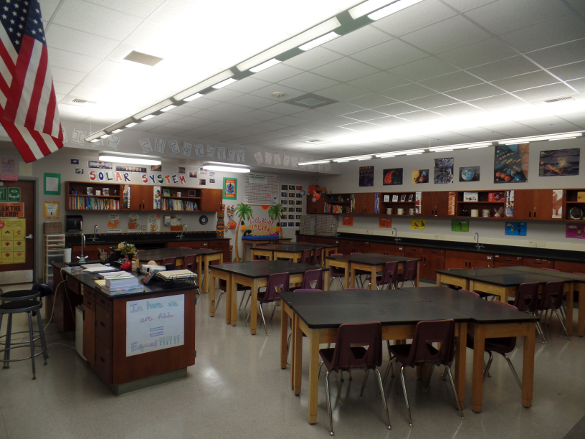
environment (Figure 2 and 3). Having an organized space with an accessible and convenient place for materials, equipment, turn-in baskets, and other items will keep things running smoothly throughout the year (Marzano et al., 2005).
Figure 1: The Ardent Teacher (2014) Science Classroom Layout

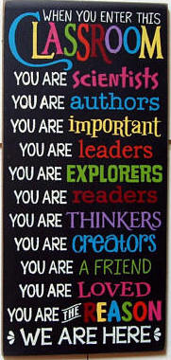
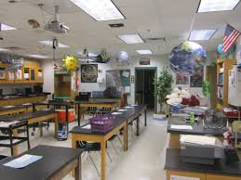
Figure 3: When You Enter Classroom (2017)
Figure 2: High School Bulletin Board Ideas (2017) Decorations

Before class ever starts, the teacher can set the stage for student-teacher relationships as well as parent-teacher relationships by sending out a welcome email or letter, or making a brief phone call to the student. It’s is critical to get to know students personally as quickly as possible to build a good rapport with them. Talking to previous teachers, preparing some “get-to-know-you” activities, and paying attention to the extracurricular activities of students are great ways to begin this process. It is also critical to have your lesson plans organized several units in advance and to be well-rehearsed for the first day of school (Marzano et al., 2005).
The first day of school is a time for the teacher and students to get to know one another a bit. The teacher’s job is to make students feel welcome, valued, and integral to the classroom, as well as to help them understand how the classroom with be run. What are the rules and expectations? Creating a syllabus for both students and parents to sign is a great way to lay out expectation specifics. The teacher should also think about seating arrangements and procedures that can be outlined on the first day. It’s boring to just take attendance, hand out the syllabus, and tell everyone where they will be sitting. Think of some interesting activities for students to get to know one another and you, as well as a content-related brain teaser, quest, game, or fun book to read to students to get them excited/intrigued about the class (Fredericks, 2005).
The teacher will spend the first few weeks of school establishing routines, enforcing rules, and getting to know students. It is important to be consistent with feedback for inappropriate behavior, to follow the rules you set up, and to let students know exactly what the expectations are for every scenario. It’s also a good idea to quickly assess where students are with reading, writing, comprehension, and previous content learning. This will give the teacher a good idea of how to accommodate, where to start, and what things to focus on initially (Marzano et al., 2005).
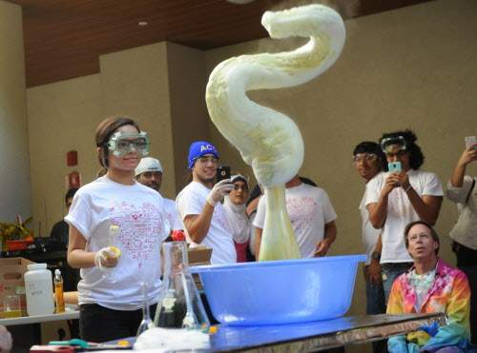
Figure 4: Elephant Toothpaste Demonstration (2015)

- Create a safe, comfortable, interesting, and effective classroom layout
- Prepare for the first day by decorating classroom, welcoming students, planning ice-breaker activities, and creating rules and procedures
- Plan to reiterate procedures and rules the first few weeks of school; help students get to know your class expectations.
Rules and Routines
A classroom without rules will result in chaos. A classroom without routines will result in inefficient use of time and materials. This does not mean that the class need to be authoritarian and rigid. The primary reason for rules is to keep both the students and the teacher safe and to create a good learning environment for everyone. Establishing a few well-thought out rules and taking the time to properly enforce them will go a long way in creating a zone of comfortable and safe learning space (Figure 5). It is also a good idea to discuss the rules and have students participate in a discussion as to why the rules may exist. This gives them something to think about when they consider not following one of them. Teachers must also be aware of school rules and enforcement/discipline policies that are in place. These can be helpful for the teacher, especially with students who are more problematic or argumentative. Having a school-wide disciplinary hierarchy helps reinforce the teacher’s authority and rules (Marzano et al., 2005).
CLASSROOM RULES
- Respect yourself and others
- Come to class prepared
- Pay attention, participate, and ask questions
- Take responsibility for your actions
- Be positive and do your best
- Clean up after yourself
Figure 5: Marlowe (2017) Classroom Rules
It is also important to get students engaged immediately upon entering the classroom. Putting a review question or science teaser on the board for students to work on right away, gets them into the mode of thinking about the content and helps them focus. Ending the class well is also important. The teacher can give students homework reminders and tips, ask them an “exit ticket” review question, or simply have everyone clear their desks and sit quietly in order to be dismissed. Having a beginning and ending routine helps keep things running smoothly (Marzano et al., 2005).
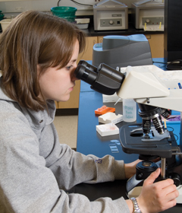
To manage transitions, it’s important to have procedures in place for common interruptions like bathroom breaks, getting computers, or switching to lab time. For unexpected transitions, getting students’ attention, letting them know the directions and expectations, and using a “go” word or phrase will help keep these moving smoothly as well (Linsin, 2015). Often transitions include using special equipment like glassware, computers, or microscopes. Along with the procedure for these particular transitions, an expectation for how equipment will be obtained, used, and replaced can be laid out. It is important that students understand how to properly care for school property that must be shared by many. The teacher should explain and model proper usage and care for each item (Marzano et al., 2005).
Figure 6: Student Looking Through Microscope (2015) Winona State University
There are a few transitions that may occur frequently throughout the school week, moving from teacher-led activities to seat work to group work. If there are guidelines for students to follow when working at their seats or in cooperative groups, these learning times will be better and more efficient for all involved. Group work can be a nightmare if it isn’t done properly. Students should have a set of guidelines to follow while working in a group or with a partner. It is also a good idea to have students frequently assess themselves and their group partners to monitor how things are going and give students a way to speak up about problems. The teacher should reiterate how important it is to listen to the ideas of others and model how to respectfully disagree with someone. Assigning groups/partners as well as appointing a leader and other positions can help create a good cooperative dynamic. Along with the regular rules and procedures, expectations for working quietly during seat work time or raising one’s hand to speak during teacher-led activities can be laid out at the beginning of the year and consistently reinforced (Marzano et al., 2005).
- Establish a set of rules and procedures that will create a safe and organized learning environment; these should coincide with school policies/rules.
- Keep students engaged from the beginning through the end of class to avoid problems.
- Have specific procedures in place for managing common transitions and group work.
Safety and Legal Requirements
A school can not function well as a learning environment without safety protocol in place. This involves not only rules regarding disciplinary action for inappropriate behavior, but also student/teacher rights and responsibilities, as well as legal and privacy regulations. The teacher must be aware of these and follow them carefully. While there are general school rules regarding behavior in the halls and parking lots and cafeteria, most disciplinary action takes place initially in the classroom. It is the responsibility of the teacher to decide which actions will result in a consequence and what that initial consequence will be. At Skyview Middle School, they have what is referred to as the “Step” program in which step one involves the teacher having the student to sit in a seat away from the class or something similar. After a short period of time, if the student has modified behavior, he may return to the normal class activities. If he continues to misbehave, step two involves a visit to the principle’s office for further disciplinary action. There are a few general rules all students are expected to follow such as keeping hands and feet to self, walking in the halls, and using “appropriate language” (Student Handbook, 2017, p. 6).
The teacher must also devise specific rewards and consequences for the rules that they decide to enforce within their own classroom. This may involve a verbal warning, moving the student to a different seat, having the student stay after class for a talk, or having them help clean up during lunch, depending on the action. The most important aspect of discipline is being equitable and consistent to all students for the same action. It is also most effective to utilize positive feedback for good behavior, not just negative feedback for inappropriate behavior (Marzano et al., 2005).
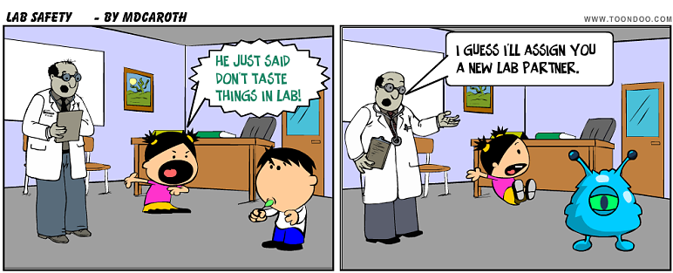
In the science classroom students will be exposed to several mild to moderate hazardous materials including biological specimens, chemicals, heat, and glassware. It is paramount that the teacher ensure each student understands all the safety rules and follows them explicitly. While Figure 7 is just a cartoon meant to be funny, this sort of thing happens all the time in high school science labs. Often teachers underestimate how much lab safety teaching they need to do, not realizing how inexperienced many student are in the science content area. The teacher should spend time instructing the students in how to put on their protective gear, how to obtain, carry, and use equipment properly, and how to handle each specific chemical or specimen they will be using during the experiential time. They also need to take the time to model appropriate response if a fire, spill, break, or contact happens. Making sure students pass a lab safety quiz with 100% accuracy is recommended. It is up to the school to ensure proper working fume hoods, fire extinguishers, and protective equipment is available and up to federal standards (NSTA, 2017).
Figure 7: Lab Safety (2008)
Below is an example of a safety quiz to administer to middle school students (Figure 8). Lab safety rules are non-negotiable and are not the same as general classroom rules, which students may help make decisions about. The teacher should give examples of why the rules are what they are and have both students and parents sign a lab behavior agreement. Science lab can be a lot of fun and an invaluable learning tool. It is recommended that students have a laboratory or field experience weekly, so it is critical that safety is first and followed (Marzano et al., 2005; Frasier & Sterling, 2005).
- Be aware of district and school privacy, legal and disciplinary policies
- Create rules and disciplinary actions for specific inappropriate behavior; maintain equitability in enforcing the rules
- Maintain a balance between positive and negative feedback
- Be vigilant about modeling, assessing, and enforcing lab safety protocol
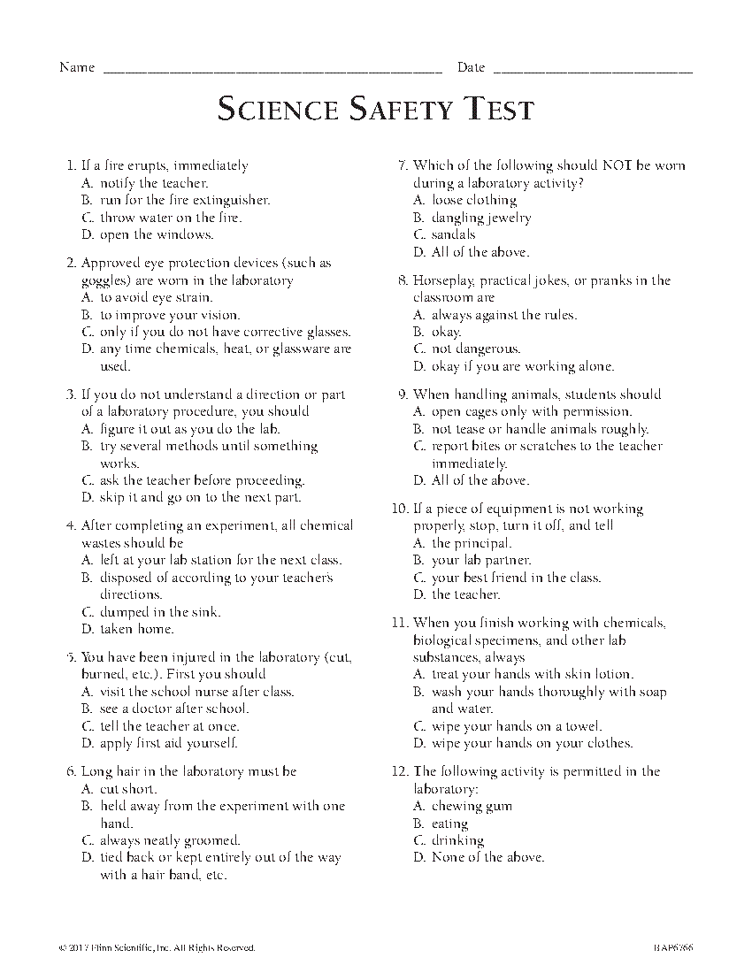
Figure 8: Science Safety Quiz (2017) Flinn Scientific

Student Engagement and Differentiation
One simple way to create a positive learning environment with fewer behavioral issues is to keep students interested and always guessing what’s coming up next. When students get bored, they often act out. When they don’t think the information is relevant to them, they will perform poorly as well. The best way to keep student engagement high is to present material in a way that is applicable to the students’ lives. Also, utilizing a variety of different teaching methods and activities will help engage all students. Often students are coming to the classroom with little to no science experience, or from different cultural backgrounds that emphasize a different style of learning. Also, they may have had some bad experiences or teachers in the science content area in the past. Any one of these can make the student apprehensive, unconfident, defiant, or shut-down about learning (Kawagley, 2006; Hulleman & Harackiewicz, 2009).
Students from other cultures may still be learning the language, therefore may have difficulty understanding a lot of the material. The great thing about science is that everyone is learning new vocabulary, ideas, and concepts, so will benefit from the extra learning tools. To support English language learners and multicultural students, having reading material at a variety of levels, listing vocabulary on the board for students to review, utilizing visual and hands-on activities, as well as pairing students in teacher-chosen cooperative pairs and groups for projects and discussions can help support these students in their learning (Vacca, Vacca, & Mraz, 2011).
Lynda Jenkins (2011) calls attention to the widespread lack of ability to apply textbook concepts to real life and practical application many individuals in science careers display, as well as a general disinterest and lack of confidence in science many students present. She attributes this to preference for the lecture and test method of teaching that so many teachers and professors use, which doesn’t help them learn to read and comprehend difficult text, support them in creative thinking, or give them practical experience relatable to their field work.
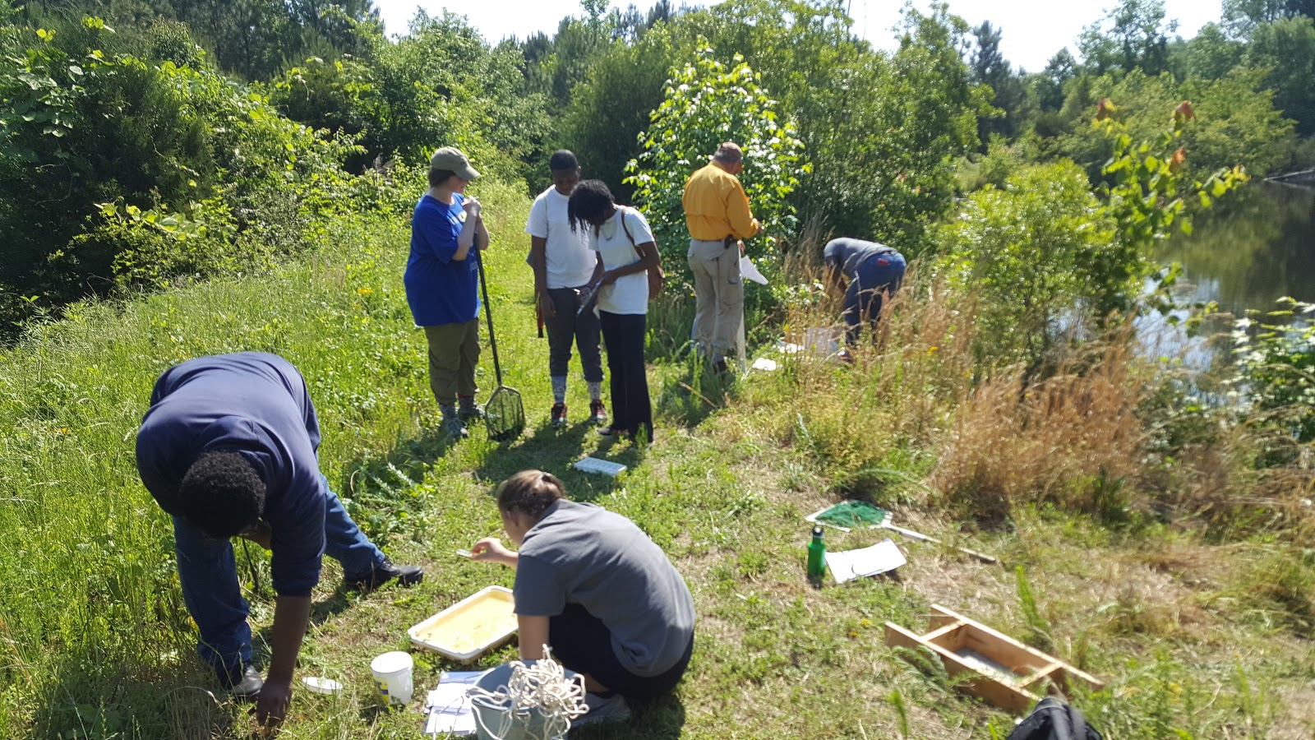
Figure 9: Knightdale High School Environmental (2017)

Beginning class with a discussion about students’ opinions of science and who a scientist is, can help the teacher understand student thought processes about the subject. The discussion can be led in a direction that gets them thinking about the fact that science is not some abstract concept, but everyday things that are relevant to life and their interests. Starting with a simple question like “How does________affect________?” about a subject they are interested in, helps guide students towards scientific thinking. The next step is to learn how to draw a correlation graph and to think about what they need to do to answer their own question (Hills, 2006, p. 61). Because the student chooses what to research, they will be more engaged, and beginning with one question and one way to present the results, creates a doable scenario in which the majority of students should be able to accomplish.
The best way to create a supportive classroom is to get to know one’s students and build relationships with them. In this way, the teacher can better understand the specific needs of different students and come up with the best way to support them. Individualized Learning Plans are the best way for the parent, student, and teacher to communicate which accommodations and supports need to be in place for special-needs students. Also, talking to parents of students from other cultures about specific cultural differences can help the teacher be more understanding of the students behaviors, questions, and needs (Marzano et al., 2005; Vacca, Vacca, & Mraz, 2011).
There are many ways to foster good interpersonal relationships with students including going to extracurricular activities, noticing little changes and commenting, complimenting students’ work or ideas, taking the time to have a little conversation or just to say, “hi,” outside of class, and making a point to get to know names, birthdays, special events, and interests as soon as possible (Marzano et al., 2005). Getting to know students also helps to predict possible problems and hopefully head them off before they become too big. Treating all students fairly and positively is also crucial. Students notice favoritism and prejudice. When students perceive that they are being supported, treated fairly, and valued, they are more motivated to learn and less motivated to cause problems (Opdenakker, Maulana, & Brok, 2011).
Bringing in members of the community to talk about and demonstrate local skills/business or a specific cultural tradition is a great way to make learning practical as well as to help students learn about and understand different cultures. When culturally relevant texts are read/provided and other cultures and languages are discussed and presented in a positive way, students are more likely to develop a global and inclusive thought process and less likely to display ethnocentrism, bigotry, or to feel inferior because of their own differences (Alaska Cultural Standards, 1998; Kawagley, 2006).
- Begin right away to develop positive interpersonal relationships with students
- Learn students’ backgrounds, needs, culture to create a supportive learning space
- Get to know students and recognize their accomplishments; be equitable and positive
- Bring in members of the community to celebrate local/global cultures
Figure 10: Alaska Native Youth Olympics (2012) Alice Strick

Figure 11: Kelvin Doe Invention (2015)

Communication and Collaboration
Incorporating the community into the classroom is a crucial aspect of creating a culturally diverse, community-oriented, practical, and engaging classroom environment. There are multiple ways to do this including involving parents and local individuals, sending students into the community to conduct research, and taking students on field trips to visit local places.
While many parents may not be willing to come and speak or demonstrate in the classroom, there are probably a few who would love to do so. Asking parents to be involved in what is happening in the classroom by inviting them to speak, to help at an event, volunteer for field trip help, or just having a conversation with them about their student and background can really help to make them feel involved, valued, and a part of their child’s education. Sending a positive letter home for every student in the class is also a good way to keep communication open and helps both you and the parents focus on beneficial traits especially in problematic students.
Field trips get students out of the classroom and into the real world, where they can utilize multiple senses to learn about an idea or concept. Field trips don’t have to elaborate. It’s a good idea to have at least one bigger field trip per semester to a wildlife refuge, a beach to observe and collect (especially with tidal pool), the museum, a fish camp, the local college, on a hike, or to a factory or business. Smaller field trips can just be going outside for an observation/documentation time, to collect specimens/samples of plants or dirt or water, etc., to take measurements, or to conduct larger experiments. Doing something different and utilizing more of the senses, keeps boredom at a minimum and engages the brain more fully in the learning experience. It’s also great to help students better understand their own environment, local commerce, how things function, and what different careers involve.
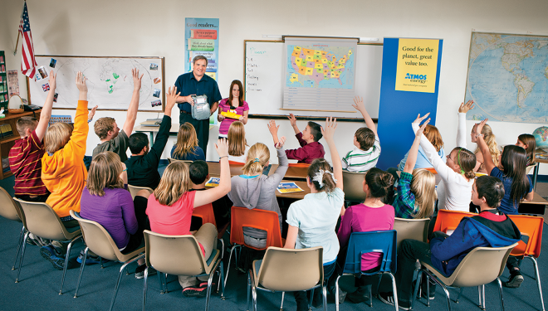
Figure 12: Atmos Energy Demonstration (2017)

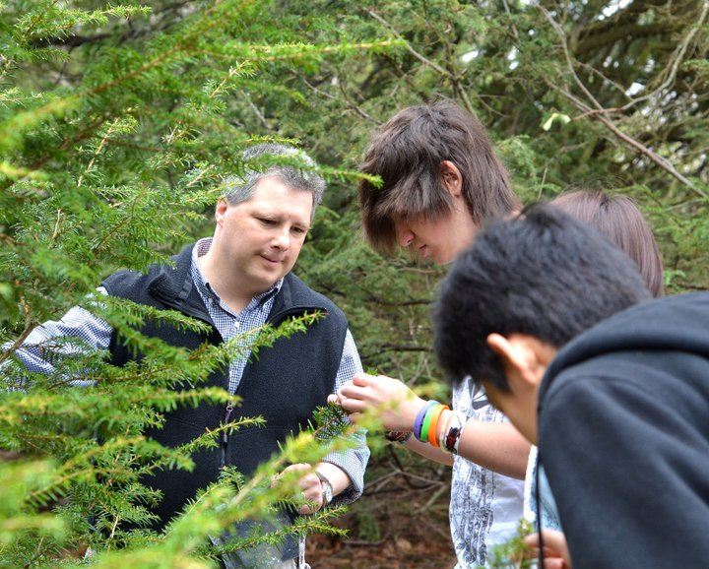
Figure 13: Anderson, K. (2011) High School Field Trip

Conclusion
Much thought and preparation goes into creating an organized, safe, welcoming, engaging, community-oriented, and practical learning environment. If the teacher takes some time to consider which rules and procedures will work best in her classroom, how she will manage and enforce them, and begins right away building caring interpersonal relationships with students, the rewards will be evident in student attitudes and performance, as well as a more smoothly functioning classroom unit (Marzano et al., 2005; Opdenakker, Maulana, & Brok, 2011). Ensuring that the lessons contain multiple aspects of learning engagement such as visual aides, hands-on application, videos, guest speakers and demonstrations, field work, and supplemental reading at different levels will help keep student’s brains active and interested (Kawagley, 2006; Vacca, Vacca, & Mraz, 2011).
While it’s great to have a plan, it’s also important to be flexible and always learning. Making adjustments to the plan throughout the year, as new information becomes available, and as experience lends new insights and ideas is wise. Before the beginning of each year or even semester, re-evaluating each rule, procedure, lesson plan, assessment, and activity for effectiveness, student engagement, and expected outcome will help to fine tune the plan. If it falls short, adjust it or exchange it for something that will hopefully work better. Classroom management is a fluid and personal undertaking that will function best when implemented properly and adjusted according to class size and location, student attitudes and abilities, school type, content area, and teacher personality. Taking the time to be an organized teacher with a plan will pay out in the long run with less personal stress, and happier students (Unger, 2011).

Websites
Science News for Students - https://www.sciencenewsforstudents.org/
- Nicely laid out science news articles for high school students
American Association of Chemistry Teachers - https://teachchemistry.org/classroom-resources/topics?grade_level=high-school
- Science lesson plans and experiments
Chem4Kids - http://www.chem4kids.com/map.html
- Simple supplemental science reading on variety of topics
National Science Teacher’s Association - http://www.nsta.org/
- Lesson Plans, Lab Safety Information, Activities, etc.
Action BioScience - http://www.actionbioscience.org/
- Podcasts, articles, research, and information on interesting biology topics for high school students

References
A Tour of My Classroom [photograph]. (2014). Retrieved from: https://theardentteacher.com/2014/09/27/classroom-tour/
Alaska Standards for Culturally Responsive Schools. (1998). Anchorage, Alaska: Alaska Native Knowledge Network.
Anderson, K. (2017). High School Field Trip [photograph]. Retrieved from: http://harvardforest.fas.harvard.edu/photos/high-school-field-trip-investigates-hemlock-branch
Atmos Energy Demonstration [photograph]. (2017). Retrieved from: https://www.atmosenergy.com/community/sharing-warmth
Strick, A. (2012). Native Youth Olympics [photograph]. Retrieved from: https://www.pinterest.com/pin/32088216072112795/
Caroth, M.D. (2008). Lab Safety [photograph]. Retrieved from: http://www.toondoo.com/cartoon/340529
Deaton, C. (2013). Teachers’ reflections on effectively managing their classroom: A discussion of how two experienced science teachers examined their classroom management practices. Reflective Practice, 14(2), 240-257. doi:10.1080/14623943.2012.749229
Eisenman, G., Edwards, S., & Cushman, C. A. (2015). Bringing reality to classroom management in teacher education. The Professional Educator, 39(1), 1.
Elephant Toothpaste Demonstration [photograph]. (2015). Retrieved from: http://www.acs-sacramento.org/delta-college-chemistry-is-everywhere/
Fowler, C. (2017). Knightdale High School Environmental [photograph]. Retrieved from: https://www.triangleland.org/company-news/knightdale-high-school-collaborative-design
Frazier, W. M., & Sterling, D. R. (2005). What should my science classroom rules be and how can I get my students to follow them? The Clearing House: A Journal of Educational Strategies, Issues and Ideas, 79(1), 31-35. doi:10.3200/TCHS.79.1.31-35
Fredericks, A. (2005). The Complete Idiot’s Guide to Success as a Teacher. New York: Penguin Group
Gregory, A., Cornell, D., & Fan, X. (2012). Teacher safety and authoritative school climate in high schools. American Journal of Education, 118(4), 401-425. doi:10.1086/666362
High School Bulletin Board Ideas [photograph]. (2017). Retrieved from: http://www.odysseycoaches.com/easy-high-school-classroom-decorating-ideas/high-school-bulletin-board-ideas/
Hills, T. (2006). Making science relevant: Using students' interests to teach the art of scientific inquiry. Science Scope, 30(1), 60-62.
Hulleman, C. S., & Harackiewicz, J. M. (2009). Promoting interest and performance in high school science classes. Science, 326(5958), 1410-1412. doi:10.1126/science.1177067
Jenkins, L. L. (2011). Using citizen science beyond teaching science content: A strategy for making science relevant to students’ lives. Cultural Studies of Science Education, 6(2), 501-508. doi:10.1007/s11422-010-9304-4
Kawagley, A. (2006). A Yupiaq Worldview: A Pathway to Ecology and Spirit (2 ed.). Long Grove, Illinois: Waveland Press, Inc.
Kelvin Doe Invention [photograph]. (2015). Retrieved from: https://www.invention.network/15-yr-old-kelvin-doe-wows-m-i-t-with-inventions/
Kock, Z. Z., Taconis, R. R., Bolhuis, S. S., & Gravemeijer, K. K. (2015). Creating a culture of inquiry in the classroom while fostering an understanding of theoretical concepts in direct current electric circuits : A balanced approach. International Journal of Science and Mathematics Education, 13(1), 45-69. doi:10.1007/s10763-014-9535-z
Kwok, A. (2017). Relationships between instructional quality and classroom management for beginning urban teachers. Educational Researcher, 46(7), 355-365. doi:10.3102/0013189X17726727
Linsin, M. (2015). The Secret to Perfect Transitions in 5 Simple Steps. Smart Classroom Management. Retrieved from: https://www.smartclassroommanagement.com/2015/01/17/the-secret-to-perfect-transitions-in-5-simple-steps/
Marzano, R.J., Gaddy, B.B., Foseid, M.C., Foseid, M.P., & Marzano, J.S. (2005). A Handbook for Classroom Management that Works. Upper Saddle River, New Jersey: Pearson Education, Inc.
NSTA Position Statement: The Integral Role of Laboratory Investigations in Science Instruction. (2017). National Science Teacher’s Association. Retrieved from: http://www.nsta.org/about/positions/laboratory.aspx
Opdenakker, M., Maulana, R., & den Brok, P. (2012). Teacher-student interpersonal relationships and academic motivation within one school year: Developmental changes and linkage. School Effectiveness and School Improvement, 23(1), 95-119. doi:10.1080/09243453.2011.619198
Science Safety Quiz [photograph]. (2017). Flinn Scientific. Retrieved from: https://www.flinnsci.com/resources/safety-reference/safety-contracts--exams/
Student Handbook/Planner. (2017-2018). Soldotna, AK: Skyview Middle School.
Student Looking Through Microscope [photograph]. (2015). Retrieved from: https://www.flickr.com/photos/winonastate/8080031470/
Unger, S. (2011). Organized Teacher, Happy Classroom: A Lesson Plan for Managing your Time, Space, and Materials. Cincinnati, Ohio: Betterway Home Books.
Vacca, Vacca, & Mraz. (2011). Content Area Reading: Literacy and Learning Across the Curriculum. Boston: Pearson.
When You Enter This Classroom You Are… [photograph]. (2017). Retrieved from: https://www.etsy.com/listing/551928965/

