Classroom Management Plan
By: Emily Severns
November 30, 2017
EDSC 458

Introduction:
Classroom management is necessary in conducting a well-run classroom. Effective classroom management leads to more engaged and behaved students, which in turn, leads to more learning in students. According to a case study by Robert Rusk, “ the teachers in Group 1 wrote fewer referrals because they clearly communicated their classroom expectations by building a sense of community and respect and by promoting good behavior through positive behavioral interventions and support (p.141).” After a study conducted on how well classroom management works on behavior and maintaining a well managed class it was found that the teachers with better classroom management skills were better able to handle misbehavior as well as other situations that may arise in the classroom. Furthermore, the study also states, “researchers have shown a lack of classroom management or less effective classroom management practices can lead to disruptions and misbehaviors that inhibit a teacher’s lesson and a student’s ability to learn (144).” The whole point of being a teacher is to help students learn, without effective classroom management that cannot happen, management is important because without it students will not listen to what you have to say.
I personally know kids need a stable and intricately managed environment to thrive educationally and socially. I have a two-year old and when he is not on a set routine his behavior can be erratic at times, when he has routines and knows what to expect he is more behaved and is able to enjoy and learn more about his environment, I find this to be the case with older students as well. When I tutored a class of 3rd grade students, I went into that job very uninformed and without the slightest idea of classroom management, I had days that were so hard because I could not get the kids to listen but looking back its because I had no classroom management skills, the kids had no idea what to expect, we had no certain rules, and the kids and I had a strained relationship because we were constantly butting heads. Having classroom management knowledge could have really helped me keep control of my class and help them learn more. As in relation to my teaching philosophy, I found that I would use a mix of information-processing and humanistic traits. On the information processing side, it would lead me to have a highly organized and structured classroom. I would direct my teaching in ways that I know my students learn best, which leads to the humanism aspect of my philosophy; I would have to develop strong relationships with my students and their parents, I would have to know what they enjoy and how to help them learn. Personalized learning, I have come to learn (Research quote), is very effective and would be a major part of my classroom and as part of my philosophy learning who my students are can help them learn more.
place holder picture have to find old class decor
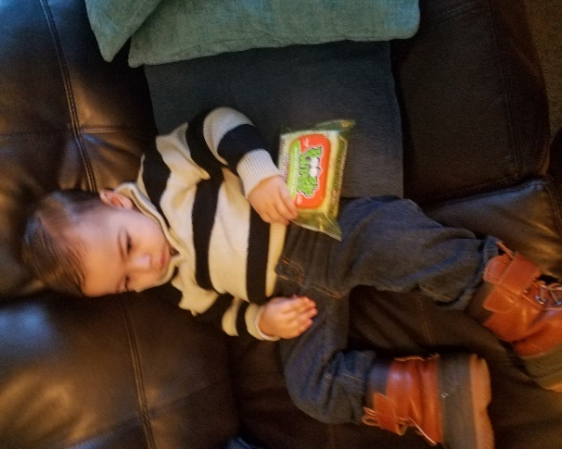
Preparation for the school year:
I believe first impressions mean everything. That means taking the time before the school year even begins to prepare the classroom and yourself for the upcoming year. I intend to put a lot of effort into the presentation of my classroom, as well as the set up and organization of the room. As a student, I remember walking into a new classroom that was decorated and inviting, and I would be in awe. This feeling made me excited to be there and ready to hear what my new teacher was going to say. I plan to take that feeling I had as a child and plan my room according to what I think would excite my students. While I do not have a designated theme for how I will decorate my room right now, I do know it will be age appropriate and more than likely based on a well-known book or author, seeing as how I will be teaching English.
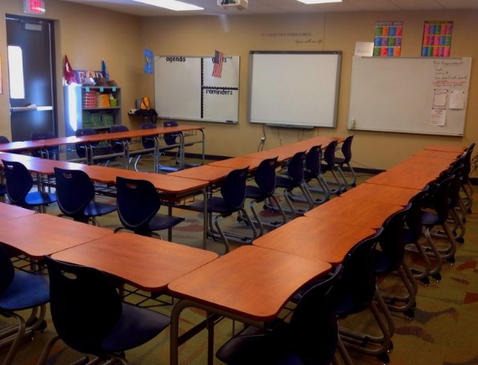
I will not have assigned seats, the students will be allowed to pick their seats on the first day and will be their set seats until mid-year when seats will be switched, this allows them to take responsibility for themselves and allows a little autonomy. I plan on trying this method out first but will make adjustments as needed. As for the desk arrangements, I would like something more modern, instead of the typical 5 rows of 5 desks. The picture shows a U shape organization of desks, every student would have a direct view of me, and I of them. I would take the bottom row and push it back just enough to make a walkway so that if necessary the students in the middle would be able to move out of the room quickly. I would place my desk in the front corner directly across from the door so that I am easily accessible to students when I am not up and walking the room.
Once the first day of classes comes around, I want to have already established a line of communication between parents and students. I will make phone calls home to introduce myself and answer any questions they may have, as well as get any information the parents feel will help me better accommodate their child. Like I stated earlier first impressions mean a lot, and by making the students and parents feel welcome and like they have a part of my room, they would be more adapt to learning. I want to use ice-breaker activities during the first one or two days of class, the text book gives some good ice breakers and I would love to incorporate the “placemat activity (Marzano 142).” An activity like this would help me get to know my students personally and begin to build strong relationships with them as well.
Rules, procedures, and routines:
I believe that my students should be involved in establishing class rules, it is their room and they should want to take care of it as well as the people in the room. I found this cute idea about meme rules on Pinterest, that I would love to incorporate in my room. I would find or make different meme rules for the room that the kids would then vote on the top 5 that they find most necessary to make into the main classroom rules. By using something the kids are familiar with you show that you can be relatable and do have a sense of humor, it makes the kids see you are human too and that you are willing to step into their world. While I want my room to be a comfortable place the students will still be expected to conduct themselves in a respectable manner and follow the rules, that we as a class, decide on. By giving them the options of rules I still have a lot of say in the rules that can be implemented but they have the final decision in which they think are most important, some of the rules that I will have as options are, be respectful, be quiet while teacher is talking, work is to be turned in on time, try your hardest, be kind, be honest, no phones, and follow directions.
Procedure and routine will play a major role in my classroom, because without it chaos would ensue. I found this out with my 3rd grade kids. They already knew school procedure but because I did not enforce the same rules the school did the kids took advantage of that. Most schools have basic procedures like walk in halls, or clean up after yourselves but unless they are enforced they will be ignored. The procedure as I witnessed in during an observation is important when it comes to getting students ready to learn, the kids are to come into class gather their materials and be seated and quiet before the bell rings. This ensures that I am not fighting to get their attention and them to settle down, for the school I observed this was school procedure because if they were not seated and ready when the bell rang they were considered late and would receive detention. This method clearly works for them so it would be nice to teach in a school that has these or implement a routine like this in own room. I will have procedures such as how to handle technology and how to act according to the incident, as with fire alarms, and the different codes. All procedures and rules will be written down and placed on a board right when you enter the room, I will also review the procedures with students in the beginning of the year as well as some time in the middle of the year, it is important that the students know what to do in the event of an emergency in order to stay safe. As for regular class routine I found, also through my observations, that a sponge activity works wonders for getting the kids engaged for the lesson of the day and helps jumpstart their brains. During the time they are working on their sponge activity I will be doing attendance and letting the kids know what is upcoming in the class or school. The sponge activity will be for the beginning of class and at the end, about 5 minutes before class ends I will address the class and let them know to find a stopping place on what they are doing, they will know to put away their materials and be in their seat and ready for me to release them. The end of class can be hectic but my students will know that I am the one who releases them and not the bell.

Discipline and Safety:
With rules I will have consequences for when they are broken, I will always try my hardest to keep the situation from escalating to a point that administration is involved. I will address my students who are being disruptive first and ask if there is a problem or what is going on, if the behavior persists, a verbal warning will be given, if I still have issues a parent will be contacted but that will be a last option. My classroom will be geared more towards positive reinforcement in the hopes that it will deter students from misbehaving. I will offer rewards such as the opportunity to listen to music during seat work, which was a strategy I observed this semester in the class I was watching, as well as homework free weekend passes. By making tangible and desirable rewards I saw that students take initiative to behave and work better.
Safety is a necessity when it comes to a classroom, students need to feel comfortable but also safe. A parent also needs to feel security that their child will be looked after and safe as well. I already talked a bit about safety but by organizing my desks in the way that I am, I am ensuring that if something ever does happen they will be safe in leaving the room. The students will also be aware of all the school procedure and my class procedures when it comes to emergencies. If they ever do need a refresher the procedures will be posted in my room.

Instruction, Engagement, and Diversity:
One of the most important parts of being a teacher is the relationships you hold with your students. I read a blog called, “The Many Hats a Teacher Wears.” It was about the many roles you play in your students lives. I find it highly relevant to the relationships you try to build with your students because in order to show them that you support them and want them to grow not only as learners but as people as well, you have to play more than just a teacher. As a believer in the Humanistic philosophy this part of my plan holds a huge spot in my class management. I mentioned I will be incorporating a lot of personalized learning in my room and the only way to accomplish this is to learn about what my student’s interests are and how they learn best, this takes effort on my part, that I am happy to put in. While not many schools have completely adopted the personalized learning method, it is my hope that I can incorporate some aspects of personalized learning. According to Lisa Spencer in her study, “Transforming Schools,”
While integrating personalized learning has been a newer endeavor for many of these schools, interesting results have already been realized. Participant 2 stated that ‘students who are progressing at a rate faster than is typically seen in classrooms, although our goal is not to increase the pace. It's really to deepen the experience. It's just that when kids have an opportunity to move forward at a faster rate, they tend to choose to do that (66).
The science clearly backs the personalized learning approach and I feel I could do my students a great service if I were put a good amount of effort into developing lessons around their own personal needs and interests.
In order to use personalized learning, I have to really know and understand my kids, how they learn, what they like or dislike, and what they’re good or bad at. There is a couple of ways I intend to go about that feat. I plan on starting before school even starts I would ask some of their old teachers what interests them or what their strong areas are. Marzano claims to be careful not to hold to tight to the views or opinions of former teachers, just like you shouldn’t judge a book by its cover, I won’t be judging my kids by the opinion of another but it would help to learn a little about them before I meet them. I also will carry conversations on with them and push for them to share their experience in class during discussion. Discussions will be a big part of my class because this is the time kids get to freely share their own views or opinions on our reading and it also helps them relate and connect life to the content.
Schools all across the United States are highly diverse, especially in Alaska and Texas (where I plan on teaching), Diverse not only culturally but by needs as well. High needs students will be in every class and it is important to know how to accommodate and assist these students. I have not taken the special needs class yet but I do have some strategies I learned from this class and some of my other education classes. Students come from all different types of backgrounds and homes, and in this class I learned the various types of high needs students from aggressive, attention problems, to the perfectionists. In my class I would like to address these situations with my students and let them know I am there to help and to be as patient as possible to work with them. ADD and ADHD students have problems focusing and a few strategies I have learned are to let the students have their space and give them a chance to walk around, or giving them an exercise ball to sit on so they can move but still be at a desk. As for the other kids who maybe aggressive, I have to remember that there is possibly extenuating circumstances that has caused this student to feel so angry, I have to be empathetic. Marzano mentions some good approaches when dealing with aggressive students, “Although aggressive students do more than try their teachers’ patience, firmness not anger, positive attention whenever possible, and creativity can help to turn their behavior around (Marzano 73).” These traits are good to use with all students but it is especially important that you use these traits with aggressive students because it benefits them to have a stable and kind person as a role model, it helps them feel safe above all else.
The load placed on teachers can really take a toll on their mental set. One study I found stated, “When teachers have positive self-efficacy relating to their classroom management practices, they have less of a chance of feeling burned-out and subsequently leaving the teaching profession (135 Rusk).” Classroom management does a lot to make sure that you stay sane because with a well-managed class you have less behavior issues and a smoother running class. The book mentioned ‘Withitness’ which is a where a teacher is aware of their surroundings at all times and deals with problems before they have a chance to occur or advance. By displaying ‘withitness’ your students know you are always paying attention and are less likely to act up making your class and job a lot less stressful. Teaching is not without stress but it is how you manage the stress that matters, if you do not accurately manage your stress you are likely to take your stress out on students or become easily upset and explode on students. That is the last thing you want to do because students will continue to push to get a rise out of the teacher if they know they can. Managing stress should be enjoyable because it involves doing something that you enjoy, for me, I manage my stress through exercise and time spent with my son, it can be different for everyone but I found my release because of the stress I deal with in school.
Collaborating with parents and Cultural resources:
Students need to be knowledgeable of their surroundings near and far as well as the close community, it is good for them to know about options for their futures and to be immersed in the society they live in. It is also necessary for teachers and students to be culturally sensitive and accepting of others traditions and customs. Some of the various ways that I can accomplish this feat is having a career day or a culture day, and having different speakers from different occupations and cultures come and speak to my students. I can also incorporate cultural diversity into the literature I teach. Find a quote from 407 textbook. By using literature that comes from ethnically diverse authors or about different cultures I can teach students to think about other peoples lives and where others come from and what traditions they may have. I would also love to use field trips to teach my students about where they are and the belief’s that others may have. Alaska and El Paso, Texas a both very culturally rich areas. El Paso has very Hispanic roots and carries a lot of the Mexican culture and traditions. I can easily find a spot for a field trip that showcases some of this culture, The Chamizal National Memorial would be a great trip to teach culture. Inviting a local writer to come speak to my class is also a good way of getting the community involved in my class, it could be a whole lesson for my kids. I can assign the reading and pair it with a class discussion as well as letters to the author, then announce that the author will be visiting and to make sure that they have questions and comments readily available to ask.
Chamizal Memorial
Community based learning helps students connect and get to know their own world, it helps them explore new opportunities and gets them excited to learn because they are experiencing what we teach them. Parents also are a part of the school just as much as the community, if not more. Parents are the ones who continue the child’s education at home. In order to make a child successful in life and school parents and teachers need to work together. Teachers need to work with parents to learn about the students and to keep a consistent line of communication open, so that the child will not fall behind. Parents should be open to helping the teacher so they can help their students, that means being open to help the child at home with homework or keeping sure their grades are doing well. I will work with parents to make sure our expectations align and make sure the students understand what we expect of them. It is important to establish this relationship with parents because you can both work together to problem solve and find what works best, it is even possible that the solution you do find can work for multiple students.
Conclusion:
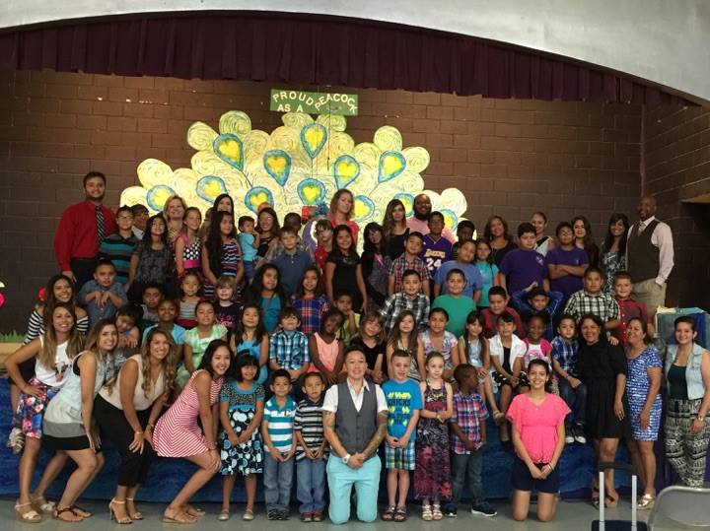
My classroom management plan at this point is strictly theoretical. While I now know what no to do in the classroom because of my prior work experience, it did give me the feel of what it is like to be in a classroom. My plan is a basis of what I would like to do in my class and I will hold on to it and make changes as necessary. Education is not a one size fits all and I will have to adjust as my students need, and that is ok, as long, as I see they are learning and growing. Class organization and developing rules together gives a sense of community so the students see that we are all in this together, therefore it is the responsibility of everyone to try their hardest in all aspects of class.
My kids and team from my tutoring position

Bibliography
K. (1970, January 01). A Love for Teaching. Retrieved November 28, 2017, from http://alove4teaching.blogspot.com/2013/04/the-many-hats-teacher-wears.html
Malmgren, K. W., Trezek, B. J., & Paul, P. V. (2005). Models of classroom management as applied to the secondary classroom. The Clearing House, 79(1), 36-39. Retrieved from https://search-proquest-com.proxy.library.uaf.edu/docview/196863668?accountid=14470
Rusk, R. B. (2016). A case study of classroom management practices and the influence on classroom disruptions (Order No. 10015230). Available from ProQuest Dissertations & Theses Global. (1767220699). Retrieved from https://search-proquest-com.proxy.library.uaf.edu/docview/1767220699?accountid=14470
Marzano, R. J. (2009). A handbook for classroom management that works. Upper Saddle River, NJ: Merrill.
Spencer, L. (2014). Transforming schools from traditional to personalized (Order No. 3682046). Available from Education Database. (1656492380). Retrieved from https://search-proquest-com.proxy.library.uaf.edu/docview/1656492380?accountid=14470

