Classroom Management Plan
Kaylee Larson
EDSC 658
Fall 2017

Table of Contents
Introduction ………………………………………………………………………..… 3
Routines, procedures, expectations………………………………………………..….4
Dealing with Behavior……………………………………………………………...... 4
Expectations as a teacher, “withitness”……………………………………………... .4
Student Relationships……………………………………………………………..….. 6
Behaving Equitably and Responding Affirmatively to Questions ………………….. 6
Beginning of the year…………………………………………………………………7
Class rules……………………………………………………………………………..7
Classroom Layout……………………………………………………………………. 8
References……………………………………………………………………………. 10

Introduction

Classroom rules and procedures are put in place for safety and order. General classroom rules are for both adolescent’s behavior and actions to ensure students are learning in a safe and positive environment. For example, “No running in class” ensures students do not trip or bump into each other. Similarly, the rule, “respect yourself and others” reminds students the behavior expected and the norm expectations on how to treat your peers. This decreases bullying and negative comments within the classroom as well as promotes a safe atmosphere for the students. Procedures are different than rules because they are more likely to vary between subjects and teachers. Procedures limit classroom interruptions These allow the class to run smoothly and instruct students in general procedures..
Other aspect of a learning environment involves not just the routines and procedures but the teacher as well. The teacher sets the mood for the classroom. If a teacher is tired and stressed their behavior shows when they teacher. Students can pick up on moods better than you know. For the teacher’s health, and the students learning, a positive mentally healthy instructor makes a huge difference. A teacher will be more patient if their mental set is on task, and are not bogged down by stress. Students learn better in a safe environment, and will be more motivated to learn when the environment is positive.
If a teacher is at their best, they can best provide for the students, part of providing for the students is developing a relationship with them. When students have a positive relationship with their teacher, they have more respect for them. There is a mutual understanding. When the teacher shows interests in the student’s life and progress, the student will live up to the expectations the teacher is set. They understand the teacher’s expectations within the classroom as well. When the teacher knows the student they can predict behaviors or avoid situations where students misbehave.
Classroom management includes classroom layout as well. The teacher will set up the room for the type of instruction they need for their content area. The room and its layout can make the room inviting and welcoming for students. In order for students to feel safe class rules should displayed and consistently practiced.

Routines, Procedures, and Expectations:
Recently published, authors Lester et al., write that classroom management and the routines associated are, “necessary for the successful facilitation of teaching and learning”(Lester et. at, 2017). In this article, authors describe the impact and important of routine in the classroom as well as the benefits it has on students’ growth. Authors later on mention that giving students a role in classroom decisions and rules gives the teacher “withitness” and can relate to students more effectively (Lester et al., 2017).
As an effective teacher it is important to establish routines for the class. Routines establish order and a better learning environment. Moreover, establishing routines for rules and procedures at the beginning and end of class utilizes all of the class time and sets the tone for learning. Lester et al., also agree that the practice of routine saves instruction time and keeps classroom order (Lester et al., 2017).

Dealing with the Behavior:

Some of the cues I have used with students are thumbs ups, positive praise, individual verbal reminders, and class praise as well. For students who are using inappropriate behavior I first say their name to draw their attention back to the activity. If that does not work, I will stand by the student or closer to them. Next, I will talk to them individually about their behavior, or address the class on which behaviors are appropriate and remind them of expectations.
In an article published in American Secondary Education, Zuckerman (2007) suggests moving towards the area of disruption. This study documented student teachers discipline strategies in the classrooms and the techniques teachers found most useful. Zuckerman agrees with our texts and states that eye contact, giving a stern look, reseating the student, or quietly directing their attention back to the asked worked for reactive responses (Zuckerman, 2007). In the European Journal of Teacher Education, authors studied teacher management strategies and compared them to students’ feelings and reactions (Roache et al, 2011). They found that the term hinting was most useful. Students even agreed that this strategy “reduced level of annoyance and distraction” (Roache, et al., 2011, p.242). Hinting is giving students reminders to stay on task, and falls into many of the verbal and nonverbal cues noted in the table above.

Exhibiting “Withitness”
To exhibit withitness, a teacher must first know what is meant by this term. Withitness has been referred to as the ability to effectively manage/ monitor the classroom to fix inappropriate behaviors and even preventatively stop them. According the Johnston (95), another definition of withitness is the “teacher’s ability to know what is going on in the classroom and to target desist behavior accurately and in a timely way” and is an important classroom management skill (Johnston, 95, p.1).
As a guide for the classroom, this can be broken down into four parts: occupying the entire room, noticing potential problems, using a series of actions, forecasting problems.
Occupying the Entire Room | Noticing Potential Problems
To fulfil this and occupy the classroom with I will use eye contact with each of the students or even position myself around the room. Although a heavy emphasis of lecture is done near the front of the class, I will try to move to the other quadrants as much as possible. By walking around the room, this limits areas of potential trouble. I will also allow me to talk to each of my students if they need help. | There are subtle hints that may indicate a problem in an area of the classroom. Even though it is natural to avoid situations where there may be trouble, these areas may need the most attention and be visited frequently while walking around the room. The more frequently this is done, the less there will be in the future. Similarly, there are clues such as students giggling at each other and student’s attention in one area of the room.
Using a Series of Actions | Forecasting Problems
When students are off task or have minor behavioral problems, I will not immediately jump to major disciplinary actions. Instead, there is a series of steps to stop the situation. These include, eye contact, moving towards the students, talking to the student privately, and making students move publicly or addressing the situation in front of the class. In an article focusing on classroom management techniques, Van Der Sijde et al. (93), discussed other steps in this series of actions. These included redirecting the student to a different activity like answering a problem, or ask the student what they are supposed to be doing (Van Der Sijde, et al, 93). | To properly forecast a problem, you must first know your students. In order to do this properly, I will have a relationship with each of my students and can better predict problems. If there have been problems in the past or behaviors during other classes keep a close eye on the student.  I will welcome students into the classroom with positive statements and greetings.

Student Relationships:

When you have communication in the classroom and short conversations with students they often share their interests. By listening to the students talk to one another, the teacher can easily pick up on the students’ interests. I usually have small conversations or take a poll in class. For example, if I am showing a problem on the board and the students are excited about the topic, then I know to do more examples or an activity with it. In the past I have had students keep a journal to write anything they want in it. Students tend to stick with topics they enjoy. As teachers we are often unaware of our students’ home lives and their experiences. Many youth are going through tough situations and school is their only save place. As educators we can look into clues based on student’s behavior to help. There are five types of student behaviors: passive, aggressive, active, attention problems, perfectionist, and socially inept. In an article published in the International Journal of Choice Theory and Reality Theory, studies found the connection between teacher-student relationships and behavioral problems. In the study researchers found that having a good relationship limited the amount of referrals as well as increased attendance and knowledge retention (Hilton et al, 2011). By having a relationship with each student, they will less likely have behavioral issues within the classroom.
To connect with students, a teacher often includes student interest into their subject area. According to our text, as well as other sources, students learn more when they are interested in the topic. When a teacher can engage students with what they like, they will pay close attention and learn more. To add to this, Englehart (2012) wrote, “where there is respect, there is less defiance and more cooperation” and continues to say relationships are highly important (Englehart, 2012) in an article on effective classroom management and teacher-student relationships.

Behaving Equitably and Responding Affirmatively to Questions
Not all students are willing to share their interests and experiences with the teacher. However, teachers can help this problem by being equitable in the class. There should not be a focus on a small group of students, but interest in all of them. Students will see this effort and will be more likely to share. There are multiple aspects of this which include body language, interaction strategies, and response to incorrect answers.
Body Language:
Eye Contact | Make eye contact with all students, not just a small handful. Scan the room are you talk.
Movement | Avoid standing in the front of the class the whole time, move around to all the students.
Listening | Practice active listening skills. This includes eye contact and looking at the student while they speak.
Positive Interactions:
· Give feedback quickly, and comment on students’ ideas and input.
· Encourage all participants in activities. Try to include all of the students in the class.
· Give students plenty of time to answer questions.

Beginning Of The year:

Some things I think about before the beginning of the year is seating arrangement and type of seating. Will having a few types of seating such as chairs, standing desks, and stools create a comfortable learning environment? Also deciding which type of seating arrangement is best for the type of instruction given. Next, I will want to make sure all materials are accessible and displayed around the room such as extra supplies, homework, and pencil sharpeners. Lastly, the posters or images in the room will create a comfortable atmosphere.
My first few goals would be to arrange the seats so all students can see the board, I can walk to each of the students, and students are relatively in the same proximity as where I teach. While teaching, it is important for me to be able to walk up to each student if they need help. By doing this, it makes it easier to builds relationships with the students. Materials should also be in a reachable area for students but not in a place where it can distract from others learning. Centers would not work well in my classroom, so materials have to be portable so the students can take them to their areas in the room.

CLASS RULES:
1.) Respect your peers, teacher and property
2.) Come to class prepared to learn: materials and attitude
3.) Try your best
4.) Be kind to everyone

CHAMPS Expectations
C: Voice level zero during instruction
Voice level 2 during partner activities/ group activities
H: Raise hand for help
A: Note taking, lecture, independent work, group work
M: Stay seated, may move to the back of the room for standing breaks
P: Activity taking notes, answering questions
S: Trying your best!

Classroom layout (Personal Drawing) 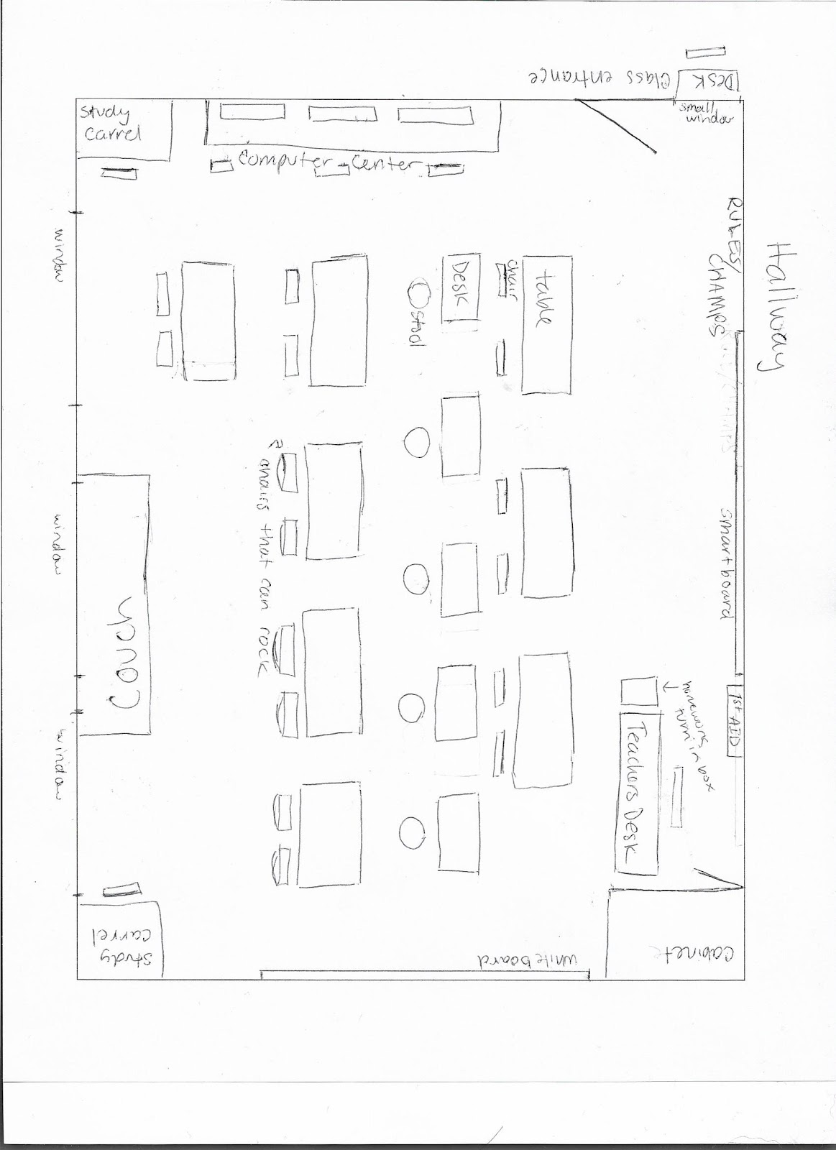

About the layout:
The partner seating provides opportunity to discuss mathematics, and separation between each allows the teacher to help each student. This is a variety of seating options to accommodate individual students needs. The study carrels provide a quiet area for students to work independently if needed. The couch in the back can provide an incentive for seating and gives students a safe place in the room. By having a variety of seating, computer area, and lecture space this classroom can be adapted for personalized learning easily.

References:
Brock, L. b., & Curvy, T. W. (2016). The Role of Children’s Adaptability in Classrooms Characterized by Low or High Teacher Emotional Support Consistency. School Psychology Review, 45(2), 209-225.

Englehart, J. M. (2012). Five Half-Truths about Classroom Management. Clearing House, 85(2), 70-73.

Jones, S.s., Bailey, R, & Jacob, R. (2014). Social-emotional learning is essential to classroom
management, Phi Delta Kappan, 96(2), 19-24
Johnston, D.B. (95). ‘Withitness:’ Real or Fictional? Physical Educator, 52(1). Retrieved
October 19, 2017.
Macuka, Ivana., Buric, Irena. &Sliskovic, A. (2017). Emotional Experiences as
Predictors of Teachers’ Mental Health. Psychological Topics, 26(2). Retrieved October
19, 2017.

Rawlings Lester, R., Bolton Allanson, P., & Notar, C. E. (2017). Routines
are the Foundations of Classroom Management. Education,137(4), 398-
412. Retrieved September 7, 17.
Roache, J., & Lewis, R. (2011). The carrot, the stick, or the relationshop:what are the effective
disciplinary strategies? European Journal of Teacher Education,34(2), 233-248.
Retrieved September 21, 2017.
Van Der Sijde, P. &Tomic, W. (93). A Model for Classroom Management Activities.
Education, 113(3). Retrieved October 19, 2017.

Zuckerman, J. (2007). Classroom Management in Secondary Schools: A Study of Student
Teachers' Successful Strategies. American Secondary Education,35(2), 4-16. Retrieved
September 21, 2017.

