Nic Sweet
Classroom Management Plan
EDSC 658
Instructor Ute Kaden
2014

Introduction:

The most effective learning takes place when students are not afraid to take risks (Marzano,2008). Making mistakes is as much a part of life as it is vital to learning. This may be most important when it comes to the arts. I feel it is equally important that teachers also should not be afraid to call out students where those students need to improve. In art rooms in in particular, falsely positive reinforcement is ,in my mind, a mistake that can ultimately hurt a student. It is easy to say, ”that’s great” even if an art teacher thinks the opposite.

My teaching philosophy as an art teacher is that I am there to help them execute their ideas as well as to facilitate the learning of mediums. This may seem like a simple approach, however if you take into account that there are dozens of media e.g. oil, charcoal, watercolor, digital, clay etc... and each one can take years to master, it seems the most logical pursuit as an arts educator.

Preparation before the school year starts:

For me, the more time I take in the “off season” to work in different media, the better prepared I will be to impart knowledge and maintain “withitness” (Manzano, 2008). The first thing we did in my student teaching was inventory. Once we did that, assessments could be made as to what needs to be ordered with priority going to what should be ordered first according to budget. There are a list of questions I need to ask myself at this time: What is my budget? Do I have to wait for lab fees? Can I ask the school for extra monies that may be needed to cover supplies not covered by the budget? Then it’s a simple matter of ordering what we can and working with what we have.

The desks in an art room should be able to be easily moved around. Depending on your week-by-week lessons, you may need a differing set up, such as if there is a still life or life drawing the focus will be the center of the room. Another issue can be that some art rooms will have tables bolted to the floor and in that case, short of calling a carpenter, you have to roll with what you have.

Now you have to go over who will be in the class. What do you know about the students? Have you met them or know what kind of work they are into? Students are not stimulus response machines.I believe you should always respect that not every student will react the same way to a project. Behaviorism may work in lab tests but remember students can be unpredictable...not “bar pressing rats”(Chomsky 67).

Another preparatory issue is art history. Since student knowledge varies, I do not have an issue teaching art history. I have recently taught an introductory lesson on aesthetics to high school and middle school students. Sometimes it is necessary to integrate this into your lessons, so that the students can further understand the exact how and why of what they are doing. ”The recent emphasis on the need for academic rigor in art education by the Getty Center for Education in the Arts (1985) has strengthened the concern long held by art educators that art is a basic subject. Greer (1984) has argued persuasively that art education, with its emphasis on four areas; creating art, art history, art criticism, and aesthetics, is an essential ingredient in school art curricula. Art teachers must develop art programs that go beyond the established tradition of merely creating art works; students must be immersed in all aspects of the structure of art in order to create and synthesize new artistic knowledge (Zimmerman, 1984). “ (Galbraith,1986). However, unlike Galbraith, I do feel that teaching four subjects in one classroom, despite their relation to the arts, is asking too much of a teacher. While I do not disagree that Art History, Aesthetics or Art Criticism are valid subject for secondary students ,if we are to teach these subjects, they should be separate subjects from studio art. The example was given ”Most teachers had taken a number of undergraduate and graduate courses in art history...The art teachers seem amply qualified to teach some aspects of art history to their students.“ (Galbraith,1986). Thusly most art teachers are ready to teach those subjects, however in college those subjects were quite separate from our studio arts classes and the instructors were specialists in those fields. This is a fantasy solution that we will be able to fit 20 college credits of information into one semester of secondary education. I am prepared to have those aspects in my classroom, but only when I can integrate it into lessons where students actively create art.

Five Keys For Preparation in an Arts Based Classroom
- Writing Lesson Plans
- Doing the research: online resources
- Some preparation happens before the preparation happens(i.e. what are your life experiences?)
- Have you tried out the art projects you are teaching?
- Do you have a solid grasp of what art is? i.e. art and aesthetics. How do you live with your senses? Have you experienced beauty? The sublime? Can you express what it is to be human?

This is something I meditated on a lot before I even set foot in the classroom. I have a sketchbook where I jot down a bunch of ideas for lesson plans, philosophies, etc. just to get my mind on the right path. I knew from previous experience from college and doing freelance that if I’m not prepared, I’m more likely to freeze up. For me, being able to respond quickly to situations that arise hinges on being comfortable in those situations, and that preparedness helps me to go into classrooms with confidence.

Policies and Procedures:

- Students will be expected to participate. (Not participating is the only way to fail in art)
- Students have bargaining power as a group. (If the students have a problem they are free to elect a representative to bring a topic for discussion and/or make requests about what is being taught. A teacher is in the service of students NOT the other way around.)
- Students WILL be respectful. (Of one another, the staff, the studio)
- Students can negotiate the parameters of any assignment. (i.e. The student wants to use spray paint instead of acrylic paint for the picture of Dr. Jekyll and Mr. Hyde in two weeks)

Safety:

The biggest concerns in an art room are knives and toxic chemicals. Knives are mostly used for printmaking. Students should know how to hold a plate and to cut away from themselves. Proper disposal of linseed oil rags is in a drum to be taken to the local dump. Alternatives can be used for the more “dangerous” supplies, such Turpenoid instead of turpentine. Akua makes a wide selection of soy based inks that are also non-toxic. Having good ventilation is essential to avoid breathing silica dust when doing ceramics. Consult materials manuals whenever possible to be knowledgeable of potentially harmful supplies. For primary school, there are generally non-toxic alternatives to many mediums. Even at the secondary level, there have been steps made to make what was formerly toxic, non-toxic.

Having respect for the work space is vital for safety in an art studio. There maybe a different outline needed from project to project to protect from hazards such as dust, knives, or paint that are all important for every student to understand.

I have not yet had to take any action besides isolation and conversation. Once I did have to ask my supervising teacher to reinforce what I was attempting to communicate with the student. The student had picked up a heavy metal grate that all students had been notified not to touch. I told him this grate is heavy and dangerous for a younger person to handle. Even after the warning, he picked up the grate and then dropped it. I had asked him to stop before he dropped the grate. Afterwards I set him aside and spoke at length about the safety concerns involved, to which he did not seem to understand and was playing games, dodging responsibility etc. I feel if I were the regular teacher in the situation and did not have another teacher in the room I would have brought the matter to a principal or parent as a follow-up if he didn’t respond to the instructions. I brought the matter to the classroom teacher, we took turns talking with the student until we felt he came to an understanding of the situation.

Student Diversity:

That academic instruction guides for teachers still refer to students as being from different races(Ryan,2013) speaks as to how far we still have to go as a people on this world . Where current scientific knowledge confirms that biologically that we are one people, there is still debate (Does Race Exist? 2014). While I do not ignore the fact that students come from different cultures, my main concern in an art studio class is upping skill level. I have used flexible grouping as a means after assessing a classes interest and skill level(Gargiulo, 2012). In a painting class I have had three or four working with airbrush based on their interest with cars. Two students are working with oils based on perceived gifted abilities and willingness to accept personal responsibility, oil paints make a mess they were willing to clean up. I have several others working with basic perspective assignments. Eventually everyone was working on technical assignments which lead to a larger group activity. It’s not culture that dictates what a student is assigned, but skill and prior knowledge.

Also it is important to keep regular communication with special education councilors and the teams involved with special needs students. My experiences in the classroom regarding students with IEP’s have been positive ones. I believe that this is because of the contact with people who are knowledgeable about situations that require extra attention. In the context of an arts classroom a student who does not respond to an assignment the way that rest of the class does can be an asset and a blessing.

Community Resources:

- Anchorage Museum
- The Native Cultural Heritage Center
- The Loussac Library
- Anchorage/Alaska Parks
- The Sealife Center in Seward/The Alaska Zoo

Getting outside the classroom is always a good thing. All of the places I listed could either be for sketchbook trips or for general mind-broadening. Going to the zoo or the sea life center is a good opportunity to take that pad of paper and watercolors or markers and make some work based upon observation. Alaska is a wealth of opportunity for plein air painting at parks. If there is a project that requires in depth research, a library is a great place to go. In general, developing the habit of spending time at a library is something that will pay dividends later in life.

Planning and Conduct Instruction:

I think grabbing the students attention is the most difficult part of the job but is also very rewarding. It’s not difficult to understand the benefits of teaching personal responsibility. The more that students can self manage, the more time we as teachers can be effectively moving forward with our students. I think this is key to a good classroom. The more we can leave students to their work, the more problems when can attend to where they arise.

If a teacher wants the students attention, standing in front of the room like a stick in the mud isn’t going to do anything. Ultimately, it is not my studio, it is their studio space and feeling like it is their space is what’s going to get the student’s more involved while they work in that space. During presentations I sit next to the computer in the middle of the room or sometimes I stand in front of the class. Either way is effective, and neither is done in an intimidating posture. I am there to help and I do not go in with an attitude that I must dominate the situation, unlike what the Marzano text recommends (Marzano,2008). I have things I want to share and put people on a path to making art and part of that is being human, and them being in touch with being human. I do work in the humanities after all.

Summary:
I believe we grow more when we work with other artists, and especially when as individuals we inhabit the same room while we work. My ideal is an environment where we work hard, simultaneously respecting the importance of taking breaks and look around at what other people are doing. Students causing a positive influence upon one another and being open to being influenced is an amazing thing.

References

Galbraith, L., & Spomer, M. (1986). Does Art History Go to
School? Art Education, 39(5), 10-13. Retrieved November
30, 2014, from http://www.jstor.org/stable/3192918
http://www.chomsky.info/articles/1967----.htm Section II,
Accessed at 9:01 pm November 1st, 2014

Marzano, J., Foseid, M., & Gaddy, B. (2008). A Handbook for
Classroom Management that Works. Prentice Hall.

Gargiulo, R. (2012). Special education in contemporary society:
An introduction to exceptionality (4rd ed.). Thousand
Oaks: Sage Publications.

Ryan, K., & Cooper, J. (2013). Chapter 3, Those who can, teach
(13th ed.).Belmont: Wadsworth.

02.15.00, P. (n.d.). Does Race Exist? Retrieved December 1,2014,
http://www.pbs.org/wgbh/nova/evolution/does-race-exist.html

Graphics/Photos

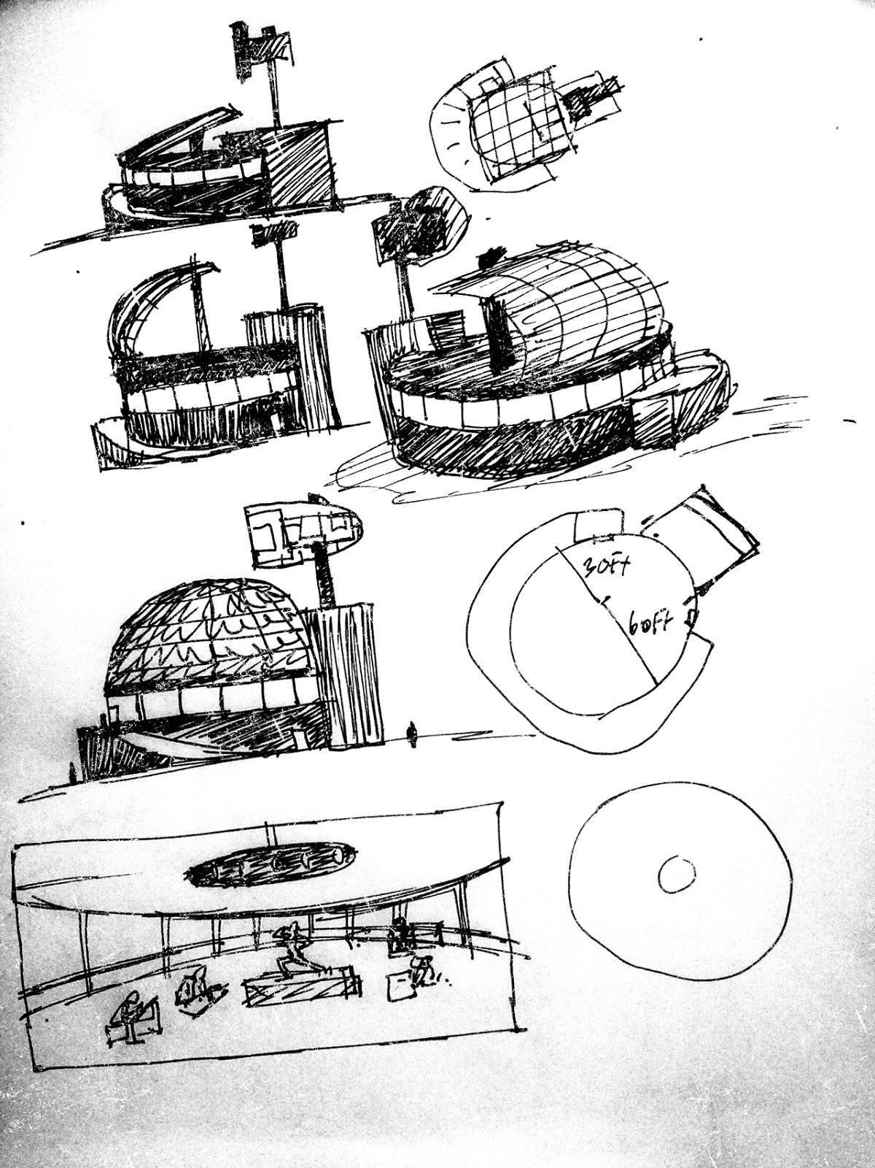
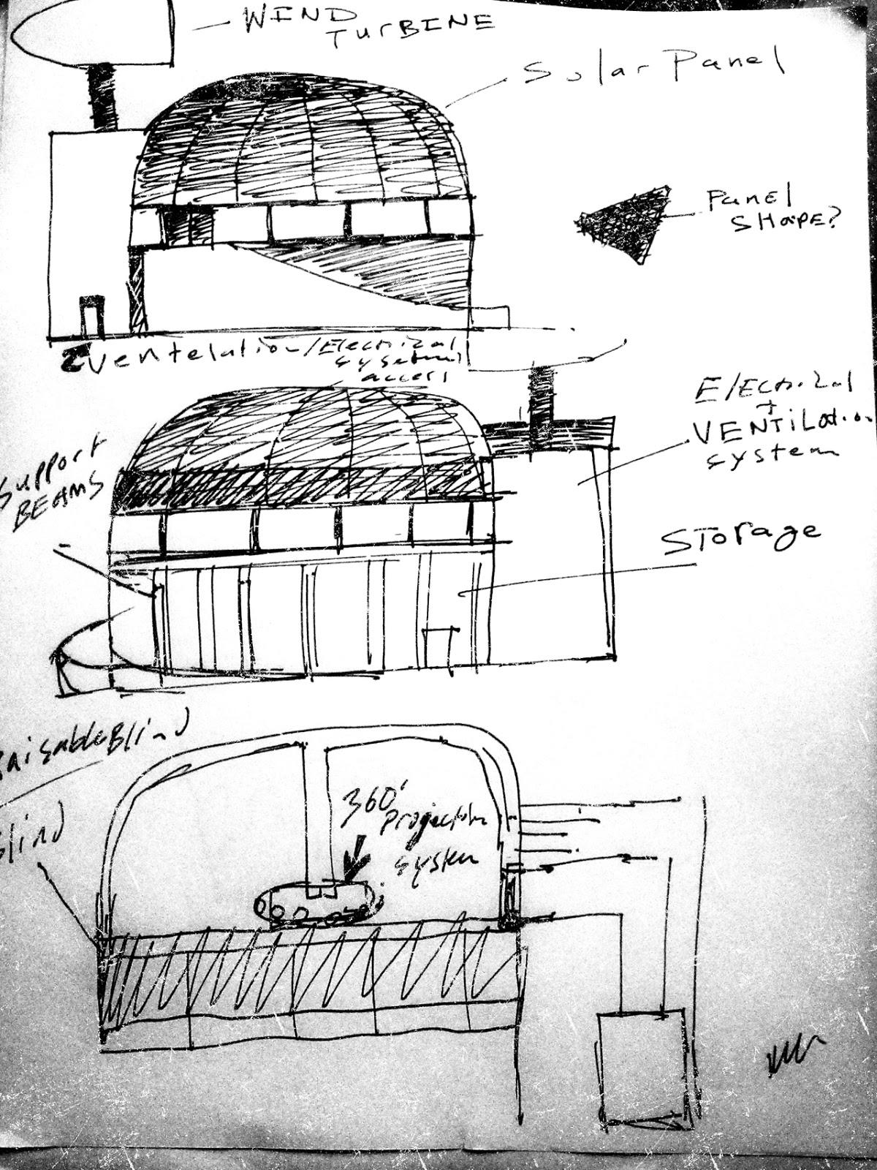
Class Room of the Future

Preliminary sketches for my dream classroom. As you can see from the first page the design went from something like a sail boat to something more like a turtle shape/geodesic dome. 60ft circumference, from the floor to the dome 25 ft, and 15-20ft high storage area underneath. The window around the structure would have a blind, that could lower or raise to accommodate studio lighting or interior 360 degree projection, an Up-to-date ventilation system. This room could be a work space and double as a gallery or theater space. This attempt includes solar and wind for energy, however hydro/tidal power is more likely in Alaska’s future. Students may or may not have access to paper. Large paper thin displays that are able to be rolled up are more likely.

