Dillon Williams
Classroom Management Plan
EDSC 658
Instructor: Ute Kaden
December 18, 2014

Introduction

Among all the challenges teachers face classroom management is perhaps the most prominent. If the situation of the classroom is out of your control then your position as an instructor is compromised by other distractions. To combat this it is supremely important that teachers be equipped with an executable, consistent, and flexible classroom management plan that will make not only their job easier as a teacher but that will also maximize their ability to serve the students and provide them with the best classroom and learning experience. Developing good classroom management and awareness takes time (Peterson, 1987). However, to develop a good strategy and 'plan of attack' before-hand will absolutely better prepare a teacher for success in the classroom and minimize the chances of burnout by setting realistic goals, following through and maintaining charge (Marzano, 2008).

Pre-Class Preparation:

Based off my own personal experience, observations, and consultation of the literature, preparation before class is one of the more important steps a teacher can take to assure classroom management success (Marzano, 2008). Some of the important factors to this are to create an appropriate classroom arrangement in terms of seating. The teacher should be placed in such a way as to occupy a position that surveys the rest of the students and in turn is visible from all seats. However, the arrangement style may be fashioned differently depending on the type of class being offered. If a class is in a lecture format primarily having the teacher front and center with the desks lined out in a row may be the best choice. However, if there's a major group component to classroom work tables may want to be chosen instead of desks and placed near to certain supplies or tools.
Another important factor is to have all the materials for instruction readily prepared, organized, and placed in an accessible location for students. This goes for classroom materials as well. Pertinent materials for any given class should be readily available for quick access. The ability to get to these supplies minimizes the amount of downtime spent in class trying to get them and reduces the opportunities for students to become off track through talking to one another, or scouring the class for supplies.
Sponge activities can also be of great benefit to students. Having these prepared for students to work on upon entry to the classroom will help minimize the amount of disruption taking place within the classroom as they enter the room (Marzano, 2007). Environment is also important. A clean, comfortable and welcoming classroom environment is a boon to student focus and a positive mental state. If the classroom is orderly then both the teacher and students will feel less cluttered. Also, if the environment is comfortable to be in students will invariably feel better disposed to being there.
Clear consequences and strategies are also greatly important. In all the successful classrooms I've encountered teachers had listed a set of clear consequences for misbehavior and strategies for dealing with unruly students. This lets the students know what is expected of them, what the consequences are for misbehavior, and helps generate an overall predictable, and routine environment.
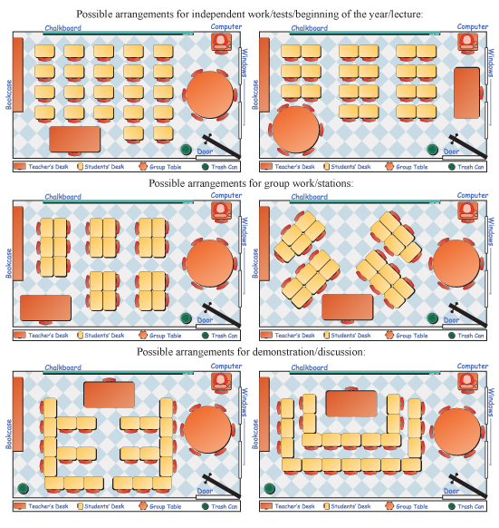

Policies:

An efficient classroom requires clear policies for the students to follow in addition to clear consequences. Each set of policies can, of course, vary between classes depending on the set of students and the personality/teaching style of each instructor. Based off of my own observations of efficient classrooms in Alaska and my own experiences with students I've developed the following non-negotiable policies on which all other student conduct is hinged. They are as follows: effort, attendance, and respect. The general rules I've developed for positive classroom expectations are the following: critical thinking, negotiation, responsibility, and respect. All of these policies will be clearly outlined and reinforced during the first part of the year and periodically throughout.
I chose the first set of rules, the non-negotiable rules, for the following reasons. Effort is absolutely required from the students in order to make progress, thus I require it as manadotry. In order to benefit from the class students are required to attend. School doesn't do the students any good unless they show up. Respect is a priority in my classroom in that all behavior hinges upon this. Furthermore the word 'respect' is great for covering multiple bases. A student can't be respectful while interrupting their classmates or ignoring instructions, for instance.
The second set of rules are things I indentify as being key to success. The first point of critical thinking is vitally important. In training students to develop this habit they will become superior problem solvers and less likely to be convinced by inferior arguments. Negotiation is a vital skill to both handle disputes, delegate tasks, and establish satisfactory terms. This step is particularly useful in the classroom in that it can get the marginally interested students invested in becoming class participants and contributors. The last point is responsibility. All students will be expected to complete work by deadlines, and take account for their actions. This is something which is instrumental to success both within school and after, and the sooner students become trained in this the higher the probability that they'll yield better results throughout their lives.
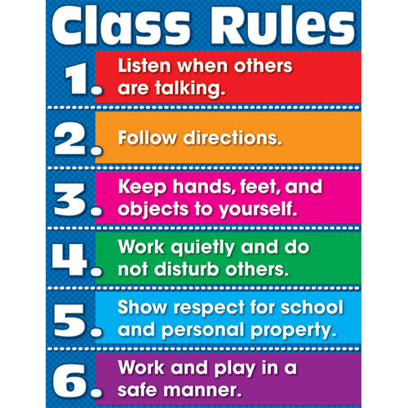

Consequences/Incentives:

Concerning consequences I view the subject from 2 categories: individual and group. Individual consequences may seem more intuitive and are carried out in a series of graduated actions (Marzano, 2007). The first infraction by a student will warrant a positive reminder. The second infraction will require that students model the expected behavior. The third infraction will be dealt with a personal conversation with the students providing one final warning and talking through how they can improve. Lastly, the fourth infraction will have the student sent to the office. These steps will be consistently enforced in order to create a predictable environment for the students while simultaneously assuring them that the teacher is to be taken seriously.
Group consequences are linked to the incentives. This category of classroom management is more strongly linked with negotiation. This strategy is utilized to change the focus from mere obedience to student responsibility; to convince the students that it is in their best interest to cooperate and be a part of the class (McLaughlin, 2012). Incentives are used as part of this negotiation process. For example, in the case of a group of younger students a teacher could offer a longer mid-class break or that if the students finish within a certain period any left-over class time is theirs. However, these incentives are to be conditional upon their performance and if the students as a group perform below clear expectations these privileges can be rightfully rescinded. This is not only a good way to have the marginal students become more invested in class but it puts pressure on the class as a whole to be self regulating in order to receive their benefits. This strategy is essentially a form of collective bargaining.

Safety and Other Considerations:

Safety procedures are generally established on a school-to-school basis. However, there are certain constants across all schools in the United States which are generally followed. First is to have a clearly marked emergency exit procedure for the class and established emergency protocol. Certain supplies are also issued to classrooms, which are often backpacks carrying certain emergency supplies and instructions. Teacher with-it-ness is required to both handle potentially dangerous situations in addition for preventing dangerous situations from happening before they begin and assessing threats. This teacher awareness is something which is honed over time and isn't something teachers are inherently equipped with, necessarily (Peterson & Comeaux, 1987).
Other considerations include students with special needs, cultural adjustment, and parents. For students with special needs it is imperative that a teacher work with the special ed. instructors and any therapists/specialists the school may have in this regard. This is to make their education be as well tailored for them as might be. Cultural adjustment can also be a barrier to success. In these circumstances teachers should seek to adjust the curriculum to best fit the students' surroundings. This is often done in the form of applied learning, which can be very effective (Morehouse, 2008). Becoming invested in the community is often a boon to teachers in these situations of cultural difference, particularly within remote/rural communities. Parents often play an important role in these situations as well.
Parents can be an excellent resource in not only these a-typical situations with special needs students and students from foreign cultures but certainly with the 'typical' classroom as well. For one thing, parents can be used as a strong outside incentive and motivator for marginal students, particularly if other management techniques have proven only somewhat successful. Parents are certainly the most effective at providing direct costs for student misconduct while also being able to provide the highest incentives as well (Marzano, 2007). Getting parents involved in other ways is also an excellent means of boosting student performance. One way to do this is to encourage parent involvement in parent-teacher conferences, activities, and perhaps even instruction. One technique that can be used is student led parent teacher conferences which provide an excellent three way discussion between all the interested parties in a student's education. Attendance to sessions like these can be boosted through creating 'mandatory' measures, such as handing out grades only at parent-teacher conferences (Lenz, 2014).

Instruction:

Typical class meetings with students will proceeded as follows: upon entry students are expected to take to their assigned seats and have their textbooks ready to hand. They are permitted to talk among themselves until class starts at which point they will be required to quickly quiet down and focus their attention on the instructor. Instruction will principally be carried out in lecture format with use of visual and audio aides. In-class readings and discussion will also play an important role in instruction.
Upon entry students will be given a brief sponge activity to warm up and review what was discussed during the last class session. Students will be expected to participate during the in-class activities and become contributors to learning. During in-class work the teacher will be moving among the students to help answer questions and also be in a vantage point to address any misconduct among the students. Homework will be handed out at the end of class and completed assignments will be collected as students enter. Weekly quizzes will also be issued at random to incentivize attendance among the students. These will also help gauge where students are at in terms of progress while giving cues to the teacher about what may be altered in terms of instruction and material.

Conclusions:

Classroom management can be a definite challenge. However, it is something which can be mastered over time and is designed to maximize the amount of benefit students receive while also boosting teacher satisfaction. Based upon my observations of successful classrooms and research I have come to adopt the following core conclusions regarding classroom management: high standards and responsibility are a definite benefit to students. Consistent, clear rules and consequences are vital, and it is absolutely imperative to seek to engage students which means being active, using various approaches/media, and teaching to ability. If students want to be in class then most of the battle is already over, paving the way for students to succeed and attain excellence within the classroom.

Works Cited:

Text
Lenz, Bob. (2014).“Using Student-Led Parent-Teacher Conferences to Build Relationships”: http://www.edutopia.org/students-conferences
Marzano, J., Foseid, M., & Gaddy, B. (2008). A Handbook for Classroom Management that Works. Alexandria, VA:Prentice Hall.
McLaughlin, James. (1994). "From Negation to Negotiation: Moving Away from the Management metaphor." Action in Teacher Education. Vol. 16, Issue 1., pg. 75- 85.
Morehouse, Lisa. (2008).“Treasured Island: Giving Students Real Skills and Real Responsibilities”: http://www.edutopia.org/small-maine-school
Peterson, Penelope L; Comeaux, Michelle A (1987). "Teacher's Schemata for Classroom Events: The Mental Scaffolding of Teachers' Thinking during Classroom Instruction," Teaching and Teacher Education Vol. 3, Issue 4, 319-331.

Images
'Classroom Arrangement'. Retrieved from: http://behavioradvisor.com/ClassroomDesign.html
'Classroom Rules'. Retrieved from: http://wilnjen.wordpress.com/classroom-rules/

