Classroom Management Plan

Sasha Graves
EDSC 485 - Kaden
University of Alaska Fairbanks
Fall 2014

Summary
This classroom Management plan is for a secondary education level Spanish class. I will be trying to challenge the students to explore new cultures and languages, which is a daunting task. One of the main reasons for learning a new language would that by becoming bilingual they double the possible people they can interact. Also they are opening new doors by being able to converse with more people and how this is an amazing opportunity. I would establish clear instructions and expectations to my classroom via a clear and concise syllabus. I would constantly be managing organization with efficiency as there are many new things to learn. I would also try and insight curiosity in my students so that they want to travel in their lifetimes and possibly achieve more than they may have with only one language as a tool.

Introduction
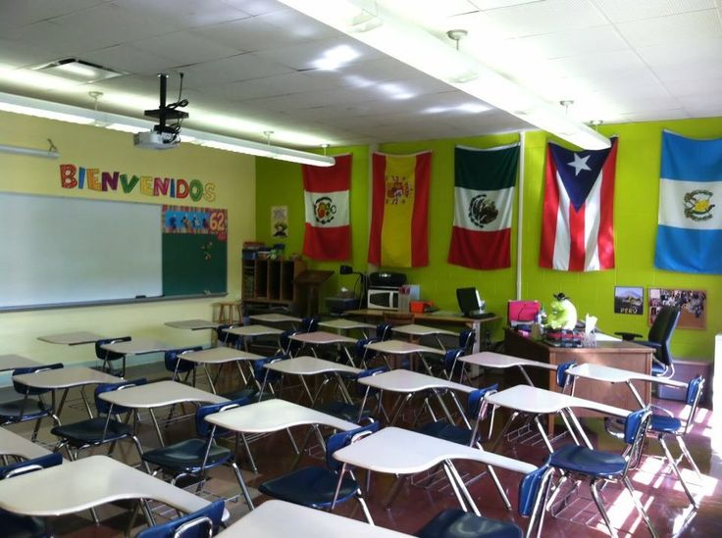
Figure 1: My dream class
The classroom is where most of the learning will take place. My classroom will be set up to be warm and inviting with many displays for the students to view. I would cover all of my walls with lots of flags and pictures. There would also be images from Hispanic/American culture to help relate my students to the topic and its concrete value. I want my classroom to feel like the student is welcome here no matter where their home country may be and would maintain an open door policy. The management and procedures in my classroom will be adaptable to a diverse population of students because I will never single out any student unfairly.
The main-stay of my classroom management philosophy is to create a warm, safe, and welcoming environment for all of my students so that their interests in a foreign language can grow and not be rejected. My classroom unit will remain unified and I will communicate with the other teachers in my department to organize language oriented activities as a department. By being active in my school community I hope to create a productive and engaging learning environment for more than one group of students. My management techniques are based on principles like respect, acceptance, grace, curiosity, and initiative. I will explicitly teach my expectations regarding each of these while maintaining an effective classroom environment.
I will model respectfulness to my students and will expect it in return. By leading the class in my expectations by actions I hope to set a good role model. I will also model acceptance in my classroom as everyone is welcome at all times. Grace will come naturally as I will struggle as a new teacher but will model how to gracefully correct myself. I would make this a class principle because I know my students will fail at first when they attempt to learn a new language. It doesn’t just show up at their doors, they need to be graceful as well as curious about the subject so I would design my classroom to incite curiosity as well.

Figure 2. The guiding principle. Respect all others and get respected.

Layout and Preparation of my Classroom:
The establishment of the culture and climate will begin before the school day starts and will end after everyone went home. I will try to establish that a diverse culture is present in America and an accepting attitude toward this is necessary for a beneficial climate and mood in my class room. The physical environment in my classroom will be changed up every semester to help introduce novelty and a variable seduction of the subject. My class sizes will vary and I expect a variety of learning styles to be present. So, I will provide my students with kinesthetic, visual, and auditory aids in the classroom. By making my decorations in class relevant, attractive, and functional I will be teaching too many different learning styles. Posters and flags will all be present as seen in figure 1 as well as a musical component that won’t be as visible but still will be present while I am trying to maintain a positive and fun work environment in class. https://www.google.com/url?sa=i&rct=j&q=&esrc=s&source=images&cd=&ved=0CAcQjRw&url=http%3A%2F%2Fwww.pinterest.com%2Fplazasantillana%2Fclassroom-fun%2F&ei=uwSBVII_iOygBJPvgGg&psig=AFQjCNEuJH6Eq5uQf1G6D09LRUVNvfX2eA&ust=1417827227544273
Rather than creating a harsh and coercive learning environment, Marzano et al. (2009) state that,” another option is to nurture students’ love of learning so that classwork is viewed not as unpleasant but something to look forward to.” (31) With the proper preparation, my students will be able to master an extended vocabulary in Spanish while learning about the various Hispanic countries, and having dance lessons bi-monthly. I would invite my students to read travel magazine and others like it to engage with their innate curiosity to explore, to listen to Pandora and Hispanic artists like Juanes, as well as focusing on broadening their sense of the Spanish culture by making it fun and inviting by incorporating Spanish poetry as well.
By doing this I would automatically be creating a sound foundation for beneficial student- teacher relations. I would only place one requirement on them, they need to try and be open to new things. By building strong personal connection (the open door policy) and maintaining consistent interactions with my students with a variety of learning styles, the disengaged student will not be a problem in my class. Also by providing feedback after every class to each student, I will be creating a positive language environment for learning a new language as well as a positive relationship with a teacher.
Starting the Year:
On the first day of class I plan on handing out a syllabus and providing both the students and parents with a clear guideline for my level of expectations. I would then spend the rest of the week doing class bonding activities like name games in Spanish and so forth. By attempting to create a firm sense of community in my classroom the students will be more engaged with

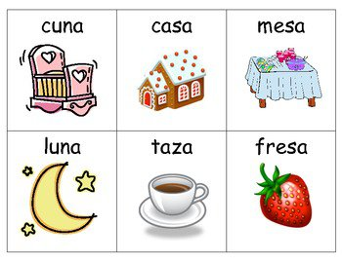 Image 3

learning the language. My lesson plans and can use peer review more than in other classes, because the student body won’t be able to ignore blaring mistakes in pronunciation and grammar if I supply a constant line of feedback. For example, I would want my students to familiarize themselves with basic sight words such as the ones given in image 3 while using stylistic devices and mnemonics to help them remember new vocabulary.

Rules and Procedures
All rules and procedures will be based on the principles respect, acceptance, grace, curiosity, and initiative. By clearly establishing the rules and procedures we as educators are providing the students with the tools necessary to ascertain our expectations as well as be prepared to maintain a job.
Since my rules will be based on my class principles, I will teach them by explaining specific situations to them clearly and what the expected behavior of them is in relation to these principles. Before preceding it is important to note that according to Simonsen et al., 2008, “Effective management in the classroom has five critical features: (a) maximize structure; (b) post, teach, review, monitor, and reinforce expectations; (c) actively engage students in observable ways; (d) use a continuum of strategies to respond to appropriate behaviors; and (e) use a continuum of strategies to respond to inappropriate behaviors.”
I plan to inhibit all five of these features in my classroom policies. I will not allow lengthy and numerous bathroom breaks, students must arrive on time or with a pass, students are also not allowed to have access to any electronic devices, and they can’t be intentionally disruptive. I would liken my rules and procedures to that of an airline. Anything we can’t do on a plane would not be allowed in my classroom either. Students much stay seated until further notice.
Figure 4: Rules and Procedures

Safety and Legal Requirements
Safety in the classroom is not something that a good teacher over looks because each one of the students matter. By managing a classroom efficiently and effectively the teacher prevents her students from harassment and negative repercussion, while educating them about what to do in case of an incident. Physical risks like fire, flooding, earthquakes, etc. would be gone over in class and have the appropriate marks on the doors and walls. All equipment for the classroom will be stored in tubs and I will keep a tidy and safe work environment for them to excel in.
For the Fairbanks School District, West Valley High School (FDWVHS), there are specific sections in the student handbook regarding the disciplinary actions. I would hate to send any of my students to the principle but if they pose a risk to others, it’s a necessity. Basic rules that do not vary from district to district like, “No Fire Arms on School Grounds” would ALWAYS be maintained in my class. These are things that every student must be aware of and maintain themselves for their safety and the safety of others.

Student Diversity
Student Diversity is the main reason I would love to be a Spanish teacher. I will be expected to maintain and engage with a variety of different cultures and academic levels while maintaining a standard for the norm. It will be a very challenging part of my job but by maintaining my classes’ principles and rules will assist me in maintaining a high quality learning environment. I will also try to work with my department teachers to reach out and engage with other students from other subjects to come and try Spanish
By making my classroom filled with flags and diagrams, along with new books for them to read as well poetry and music, the student body will be satisfied. I will always have an open door policy, even if it means no free lunch for me, so that all of my students feel welcomed and accepted. My goal is to ignite a more enjoyable learning environment for a variety of students.

Planning and Conducting Instruction:
As a language teacher I plan on consistently demonstrating “Withitness”. This means being constantly involved in my student’s academics and extracurricular. I hope to be a tennis coach as well. I would always be constantly providing them with feedback and new ideas to help them learn. Since not all language lessons can be learned in the class room I would advise them to reach out into their communities and start to speak Spanish outside of class as well.
I’d want to reiterate that although the basics of the language will come from my classroom the comprehensive part of being bilingual only comes with immersion. I know that the more they are out in the community, doing things for others, the better my students will be able to conduct themselves when they reach adulthood. I will provide a clear explanation of the dos and do not’s while going out into the community. Like do be accepting of others cultures and opinions and do not try to coerce somebody into always thinking like you want them to think. A broad perspective on life is necessary to becoming well rounded and learning a new language is a step toward that goal. I also intend to teach my students a new sense of respect for bilingual people because they went through this struggle themselves as well as grace because they will fail at the language initially. I seek to educate my students by providing them with a whole new form of communication that can empower them to receive a brighter and more versatile future. I hope that they will always be curious about new cultures, individuals, languages, and perspectives on life. This is my job as a teacher and I intend to do it to my full capacity.

References:
.Fairbanks North Star Borough School District Student Misconduct Handbook. 2014. http://www.k12northstar.org/boe/policies-regulations
Marzano, R., Gaddy, B., Foseid, M., Foseid, M., Marzano, J. (2009). Section 6: Getting off to a Good Start. A Handbook for Classroom Management that Works. Pg. 132-145.
Simonsen, B., Fairbanks, S., Briesch, A., Myers, D., & Sugai, G. (2008). Evidence-based Practices in Classroom Management: Considerations for Research to Practice. Education & Treatment of Children, 31(3), 351-380.
Reflection:
I am so excited to make education my career; I mean who wouldn’t want to teach a subject that has such a relevance to America and yet applies to the rest of the world? During this class I have learned how important classroom management skills are in providing an engaging and safe learning environment for all students. I will always strive to add to my education abilities and learn from other effective educators.
This is a great picture of Barcelona, Spain and is where I want to go first but I intend to come back to America and teach authentic Spanish from Spain plus learn Catalan, a different dialect of Spanish.
Thank you for your time,
Sasha Graves

