DRAFT: Classroom Management Plan

John Hill
EDSC 658 - Kaden
University of Alaska Fairbanks
Fall 2014

Summary
This management plan is for my secondary science classroom. The plan is designed to create a productive learning community based on respect, responsibility, diligence, integrity, and good judgment. Preparation of the physical environment and classroom procedures and rules will set the tone for the class before the school year begins. Direct instruction on these rules and procedures and consistent enforcement throughout the year, establish clear expectations for students. Physical, social and emotional safety are addressed with a focus on safety in the lab environment. School and district policies and rules will be followed. Instruction will be engaging, well planned, differentiated, and adapted to meet diverse student needs. Place-based learning, inquiry, and withitness are strategies that I will use to encourage students to take ownership of their education in our learning community.

Introduction
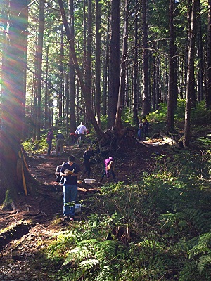
The classroom is where learning takes place. My classroom will be more than the room where my class meets. It will include the forests, fields, streams, lakes, and where ever else is logistically possible. Biology is a science of observation, exploration, and inquiry of life. Therefore, my classroom environment will necessarily include all living things that can practically be studied and learned from. Management and procedures in my classroom will be adaptable to these alternative venues.
The pillar of my classroom management philosophy is creating a productive learning community and culture. Unity and vested interest in the success of all is the ideal I strive to promote in my classroom and in each of my students. Management techniques will be based on the principles of respect, responsibility, diligence, integrity, and good judgment. I will explicitly teach my expectations regarding each of these, and be a constant, intentional model of these principles. Clear consequences and rewards will be consistently provided to help incentivize those students who are still developing their internal motivations and ability to self-regulate.
Figure 1: My classroom. Biology students collecting data on several variables in the forests of Juneau, AK.
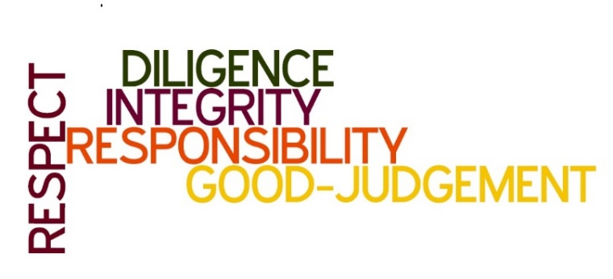

Figure 2. The guiding principles of my classroom management plan.

Preparation Before The School Year Starts
The establishment of the culture and climate described above will begin before the school year starts. The physical environment in my classroom will be well organized and accommodate a variety of activities, class sizes, and learning styles. The decorations will be relevant, attractive, and functional. Posters and manipulatives that depict biological processes, lab safety, biodiversity, structure, anatomy, and physiology will serve to pique interest and as a reference for students (Figure 4).
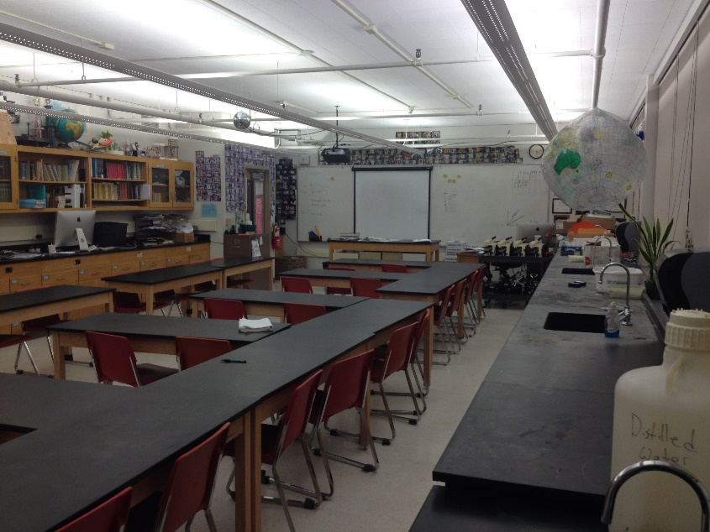
Structuring the physical environment for effective instruction and practical use will depend on the shape and size of the actual classroom. Ideally, the laboratory space will be separate from the tables where class will be held. Figure 3 shows the arrangement of desks that will be used in my classroom. This adaptive arrangement allows for direct instruction using the whiteboards or a projector in the front, as well as circling for discussions, debate, or presentations. Storage cupboards will be labeled and organized. Although each classroom space will have to be adapted, the general layout in Figure 3 is how I will organize my biology classroom.
Figure 3. Adaptive Desk Arrangement

Marzano et al. (2009) state that getting ready for the start of the year is not just organizing the physical space. Proper preparation includes setting a firm foundation for strong student-teacher relationships and preparing clear rules, procedures, and academic expectations. The first day is a valuable time to make connections with students and create in them a desire to return to learn. Welcome remarks and first lessons in my classes will be impactful and relevant.
I do not plan on using this first day to go over the syllabus. Instead, class will be an interactive activity that will immediately get students thinking about science; a lab, a demo, or some form of discussion where they have the opportunity to collaborate. I will explain the rules for such activities and general class procedures so that students will feel safe. From the first day I will treat them with respect and demand that they do the same. At the end of the first week I will present the class rules more formally and have students and their parents sign the academic discipline plan, syllabus (i.e. scope and sequence), and a laboratory safety contract.

Rules and Procedures
All rules and procedures will be based on the principles of respect, diligence, integrity, responsibility and good-judgment. Students cannot be held accountable for expectations that they do not know. Rules and procedures are the tools we use to establish expectations. Thornberg (2008) defined rules as “guidelines for actions and for the evaluation of actions in terms of good and bad, or right and wrong.” He analyzed the reasons for rules in the classroom and found there were five types: relational rules, structuring rules, protecting rules, personal rules, and etiquette rules. The students’ perception of the reason behind the rule was significant to students’ acceptance of the rule. I conclude that rules must be well reasoned and well explained for students to accept and abide by them. (See: http://www.nea.org/tools/establishing-classroom-rules.html)
Since my rules will be based on class principles, I will teach them by explaining specific situations and expected behavior related to these qualities. When I address integrity, I will tell about a few of my fellow biologists that falsified data and undermined fisheries monitoring programs and relationships between fisherman and the federal agencies tasked with monitoring fish populations. Broken relationship are the consequence of dishonesty. Integrity builds trust and unifies people. Academic honesty promotes learning and builds confidence.
Procedures will have to be taught and reinforced throughout the year. Policies on late work, tardiness, bathroom breaks, absences, and grades will be presented in the academic discipline plan. My students will be held accountable for being ready to begin class (pencils sharpened, notes out, in their seats, etc.) when the bell rings. I will also expect them to wait to be released, not by the bell and certainly not before the bell to line up by the door. Procedures will be taught by demonstration and practiced by students to ensure that they have a clear picture of what is expected of them.
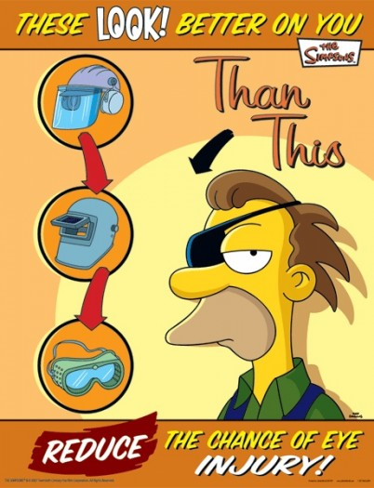
Effective management in the classroom has five critical features: (a) maximize structure; (b) post, teach, review, monitor, and reinforce expectations; (c) actively engage students in observable ways; (d) use a continuum of strategies to respond to appropriate behaviors; and (e) use a continuum of strategies to respond to inappropriate behaviors (Simonsen et al., 2008). Therefore, consequences will be equal to the severity of the offence and will escalate as non-compliance continues. Detentions are the main consequence I will employ. There will be a detention signup clipboard for students who arrive tardy, use foul language, or otherwise fail to control their comportment. Detentions are to be served within two days of receiving them. They can be served at lunch or after school. They will be required to do work in my classroom such as filing, cleaning, organizing or preparing for labs; not their own work. More serious infractions are stipulated at the school and district levels as are their consequences and I will strictly adhere to these policies (see Figure 4).

Safety and Legal Requirements
Safety in the classroom in not just mitigating the presence of physical dangers, it involves the social and emotional safety of students as well. Classroom management is vital in the school-wide effort of protecting students from bullying, unwarranted social pressures, and preparing them to deal with the stresses of high academic expectations. In my class, I will stress respect and good-judgment as principles that can be applied to reduce these risks. Physical risks still remain the most obvious and most planned for safety concern.
Figure 4: Lab safety posters promote safety. (Source: http://goo.gl/G9UUuM)

Rules and procedures specific to lab and field safety will explicitly taught and will depend on the specific lab or field situation. Teaching science students the class procedure for by using chemicals, lab equipment, and personal protection equipment can be tedious, but I will make it relevant with real examples and consequences of rule breaking. If students are told real stories of past-students who had to pay to replace a broken microscope, they are more likely to careful follow rules regarding their use. If they see the effects of acid on an egg as an analogy to getting acid in their eye, they will wear their goggles more willingly. By describing these rules in the context of the lab that students about to participate, I will help them conceptualize the instructions, and give them a “need to know.” There will be no tolerance for unsafe behavior in the laboratory setting. Consequences for safety infractions will be immediately and consistently enforced.
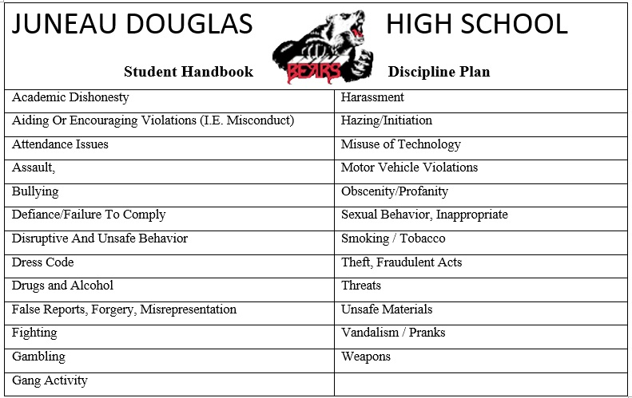
Established procedures related to transporting, using, and storing chemical will be a safety priority. Whenever possible chemicals will be handled solely by adults. Safety will begin by having the students and their parents understand and sign a safety contract regarding the hazards of lab activities. This includes things as simple as wearing the proper personal protective equipment. I will conform to the procedures taught in the Flinn Scientific High School Laboratory Safety Course (http://labsafety.flinnsci.com/Home.aspx). Eye wash stations, fire extinguishers, first aid kits, and other emergency equipment will be checked bi-annually by me, regardless of, or in addition to the verification system established by the school. Building specific safety concerns such as fire evacuation routes, lock down procedures, and medical emergency response protocols will be posted on or by the door. My classroom will conform to all safety requirements and protocols.
Figure 5: Student Code of Conduct based on Juneau School District rules for student conduct to promote safety and to protect the learning environment.

Legal issues are addressed in the student handbook produced by each school and school district. For the Juneau School District’s Juneau Douglas High School (JDHS) there are specific sections regarding the behavioral issues listed in Figure 5, and their consequences.

Student Diversity
In the students of every classroom there is a range of academic ability, motivation, self-control, and external influences that affect productivity. Organization, communication, and collaboration will allow me to clearly deliver instruction and place responsibility on every students to create knowledge by producing evidences of their understanding. I will reach students at all cognitive levels and abilities through challenging, adaptive, differentiated instruction. For students with learning disabilities, I will be provide them with appropriate accommodations and modifications to ensure all students have an equal opportunity to learn. Inclusion of all students requires creativity but is a duty I accept. (See ASCD article on Inclusive Education: goo.gl/yy0GLw)
Cultural diversity in Alaska is an opportunity to benefit from diverse sources of knowledge. Semken (2005) stated that place-based teaching values indigenous knowledge and should incorporate experiences outside of the dominant culture (as cited in Zimmerman & Land, 2014). As an educator, I will use a place-based approach to integrate traditional knowledge, Native culture, language, and values into the curriculum.

Planning and Conducting Instruction:
If you fail to plan, you plan to fail. This adage holds true in education. To provide my students with quality instruction, I will prepare for and conduct my classes using the research-based strategies of place-based learning, inquiry, and withitness. (See NABT: goo.gl/Tr2zZY)
Place-based education will be used in my class as a strategy to improve student engagement and motivation. Students in my classes will be challenged to apply the knowledge they are learning immediately to solve issues and problems in their community. This infuses school experiences with value and meaning for students. The power of relevancy is that education is no longer an abstract and faraway thing but instead becomes an opportunity to make change and contribute to the welfare of others (Smith & Sobel, 2013).
Teaching science as a process through inquiry, increases student-engagement and their ability to learn at higher cognitive levels. The combined value of teacher effectiveness in classroom management and inquiry based science instruction has the potential to produce greater student achievement. Adapting research-based strategies to the unique classroom management issues in science classrooms will increase instructional time and learning environment quality.
While conducting instruction in my classroom I will exhibit “withitness.” Marzano et al. (2005) summarized withitness using four teacher behaviors: occupying the whole classroom, noticing potential problems, using a series of graduated actions, and forecasting problem. Resolving incidents effectively requires that the correct student is targeted, the timing of the response is appropriate, and the reaction fits the situation (Johnson, 1995)
The day to day structure and management of my classroom will create accountability in education. Students will take ownership for their own progress. Once again, my goal is to develop integrity as a holistic character trait. Einstein said: “The discovery of the laws of nature – the science – makes the erudite man, but does not make a man good. A good man is one who holds the values that are within your consciousness.” Thus: “The instructed man is erudite. The educated man is good” (Campos Marques, 2011). I seek to educate my students.

References
Campos Marques, A. C. (2011, January 23). Education of the Integral Man. Sustainable Thinking. Retrieved from http://sustainabilitythinking.wordpress.com/2011/01/23/education-of-the-integral-man/
Johnston, B. D. (1995). `Withitness:' Real or fictional?. Physical Educator, 52(1), 22.
Marzano, R., Gaddy, B., Foseid, M., Foseid, M., Marzano, J. (2009). Section 6: Getting off to a Good Start. A Handbook for Classroom Management that Works. Pg. 132-145.
Simonsen, B., Fairbanks, S., Briesch, A., Myers, D., & Sugai, G. (2008). Evidence-based Practices in Classroom Management: Considerations for Research to Practice. Education & Treatment Of Children, 31(3), 351-380.
Smith, G., & Sobel, D. (2013). Bring It On Home. Independent School, 72(3), 94-102.
Thornberg, R. (2008). School children's reasoning about school rules. Research Papers In Education, 23(1), 37-52. doi:10.1080/02671520701651029
Zimmerman, H., & Land, S. M. (2014). Facilitating Place-Based Learning in Outdoor Informal Environments with Mobile Computers. Techtrends: Linking Research & Practice To Improve Learning, 58(1), 77-83. doi:10.1007/s11528-013-0724-3

Reflection: As a pre-service teacher there is an excess of theory and a lack of experience. This classroom management plan reflects this condition.

