Classroom Management Plan

Introduction:
When looking at creating a productive learning environment, I really want the students in my future classroom to understand how important it is for them to be engaged in their own learning process while participating in the process of learning secondary mathematical concepts in class. I do not feel an absolutely quiet room with no interactions with the teacher or others is conducive to a positive learning environment. However, I am still learning how to effectively manage the classroom in a way that the students are not only comfortable/safe in asking questions when they do not understand a concept, but also feel comfortable enough to contribute to a solution or to solve an equation on the board when asked. The fine line between conversing to get a clearer picture of the concept and talking to your neighbor regarding plans for the upcoming afternoon or weekend is one that students tend to cross (especially those students who are not interested in mathematics).
One strategy I have seen employed in a secondary level math class is the teacher mentioning areas in the subject that she herself may have had to work harder at versus other areas that were not so hard. By sharing this with her students during a lesson when the concepts started to get a little harder for the students, it made the idea of them struggling at first appear to be okay, a logical process that many go through and that by persevering through it, they too will have the ability to learn the concept/skill. I myself have made a note to my own students of situations where I have had to exhibit perseverance in order to grasp the subject/concept. I also have noted in the past that I am not perfect and should anyone notice a mistake or calculation error to please speak up and share that with me/class (in a positive/respectful way).
Authors R. Marzano, B. Gaddy, M. Foseid, M. Foseid, and J. Marzano who have heavily researched the topic of classroom management, by performing more than 100 studies and have published their findings in a book called “Classroom Management That Works.” (Marzano, et al, 2005) They have recognized seven major elements amongst those teachers who exhibit effective classroom management. I will be using these research proven elements in my classroom management plan, but not necessarily in the order listed below:

• Rules and procedures
• Discipline and consequences
• Teacher-student relationships
• Mental set
• Student responsibility
• Getting off to a good start
• Management at the school level (Marzano, et. al., p. 1, 2005)

Preparation before the school year starts- Getting off to a good start:
Prior to the beginning of the school year there are many decisions that need to be made regarding planning a whole infrastructure for building a positive learning environment for the students that I will be serving throughout the year. Effective classroom management begins even before students arrive at school.
In being prepared for the new school year I must already have in place a completed outline of my plans for the whole school year, since I will be teaching mathematics and most secondary math courses are a year in duration. I will need to align all of the State and National content standards to the curriculum I am being provided by the School District where I will be teaching. Collaboration between myself and the other same subject secondary teachers will be high upon my preparation list when determining how to achieve teaching all of the standards required for the subject and grade level I will be teaching.
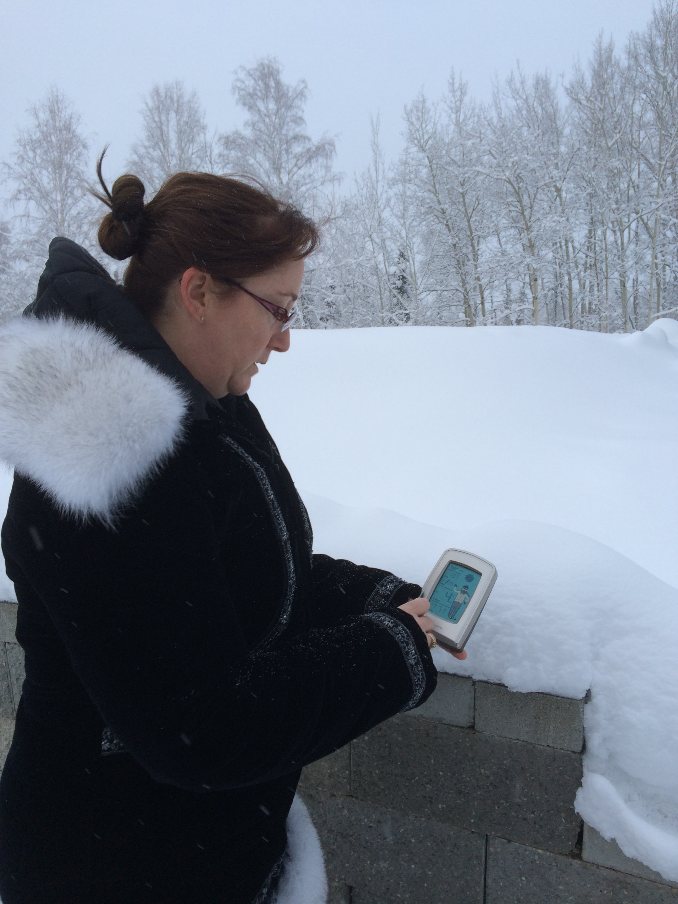
In order to be prepared starting on day one, I must have the tools in place to implement the lessons and activities that I plan on teaching. This will usually involve all sorts of supplies, tools (calculators), scissors, glue sticks, pencils, pencil sharpeners, paper (lined, blank, graph), files, folders, cabinets, storage containers to organize and readily have the supplies available to students and myself for use. The Alaska State Technology Standard-- Standard C states “A student should be able to use technology to explore ideas, solve problems, and derive meaning.” Since I will be teaching secondary mathematics, this means I will need to research the types of technology I will have available to help me enhance and engage the students in their learning of the mathematical concepts required to meet the local, state, and national standards. This includes noting the software, apps available, and how to implement the use of said technology. How to run it, fix it if an error occurs, monitor the student usage while utilizing it and having a plan in place for make-up work should a student not be present on the day it is used.

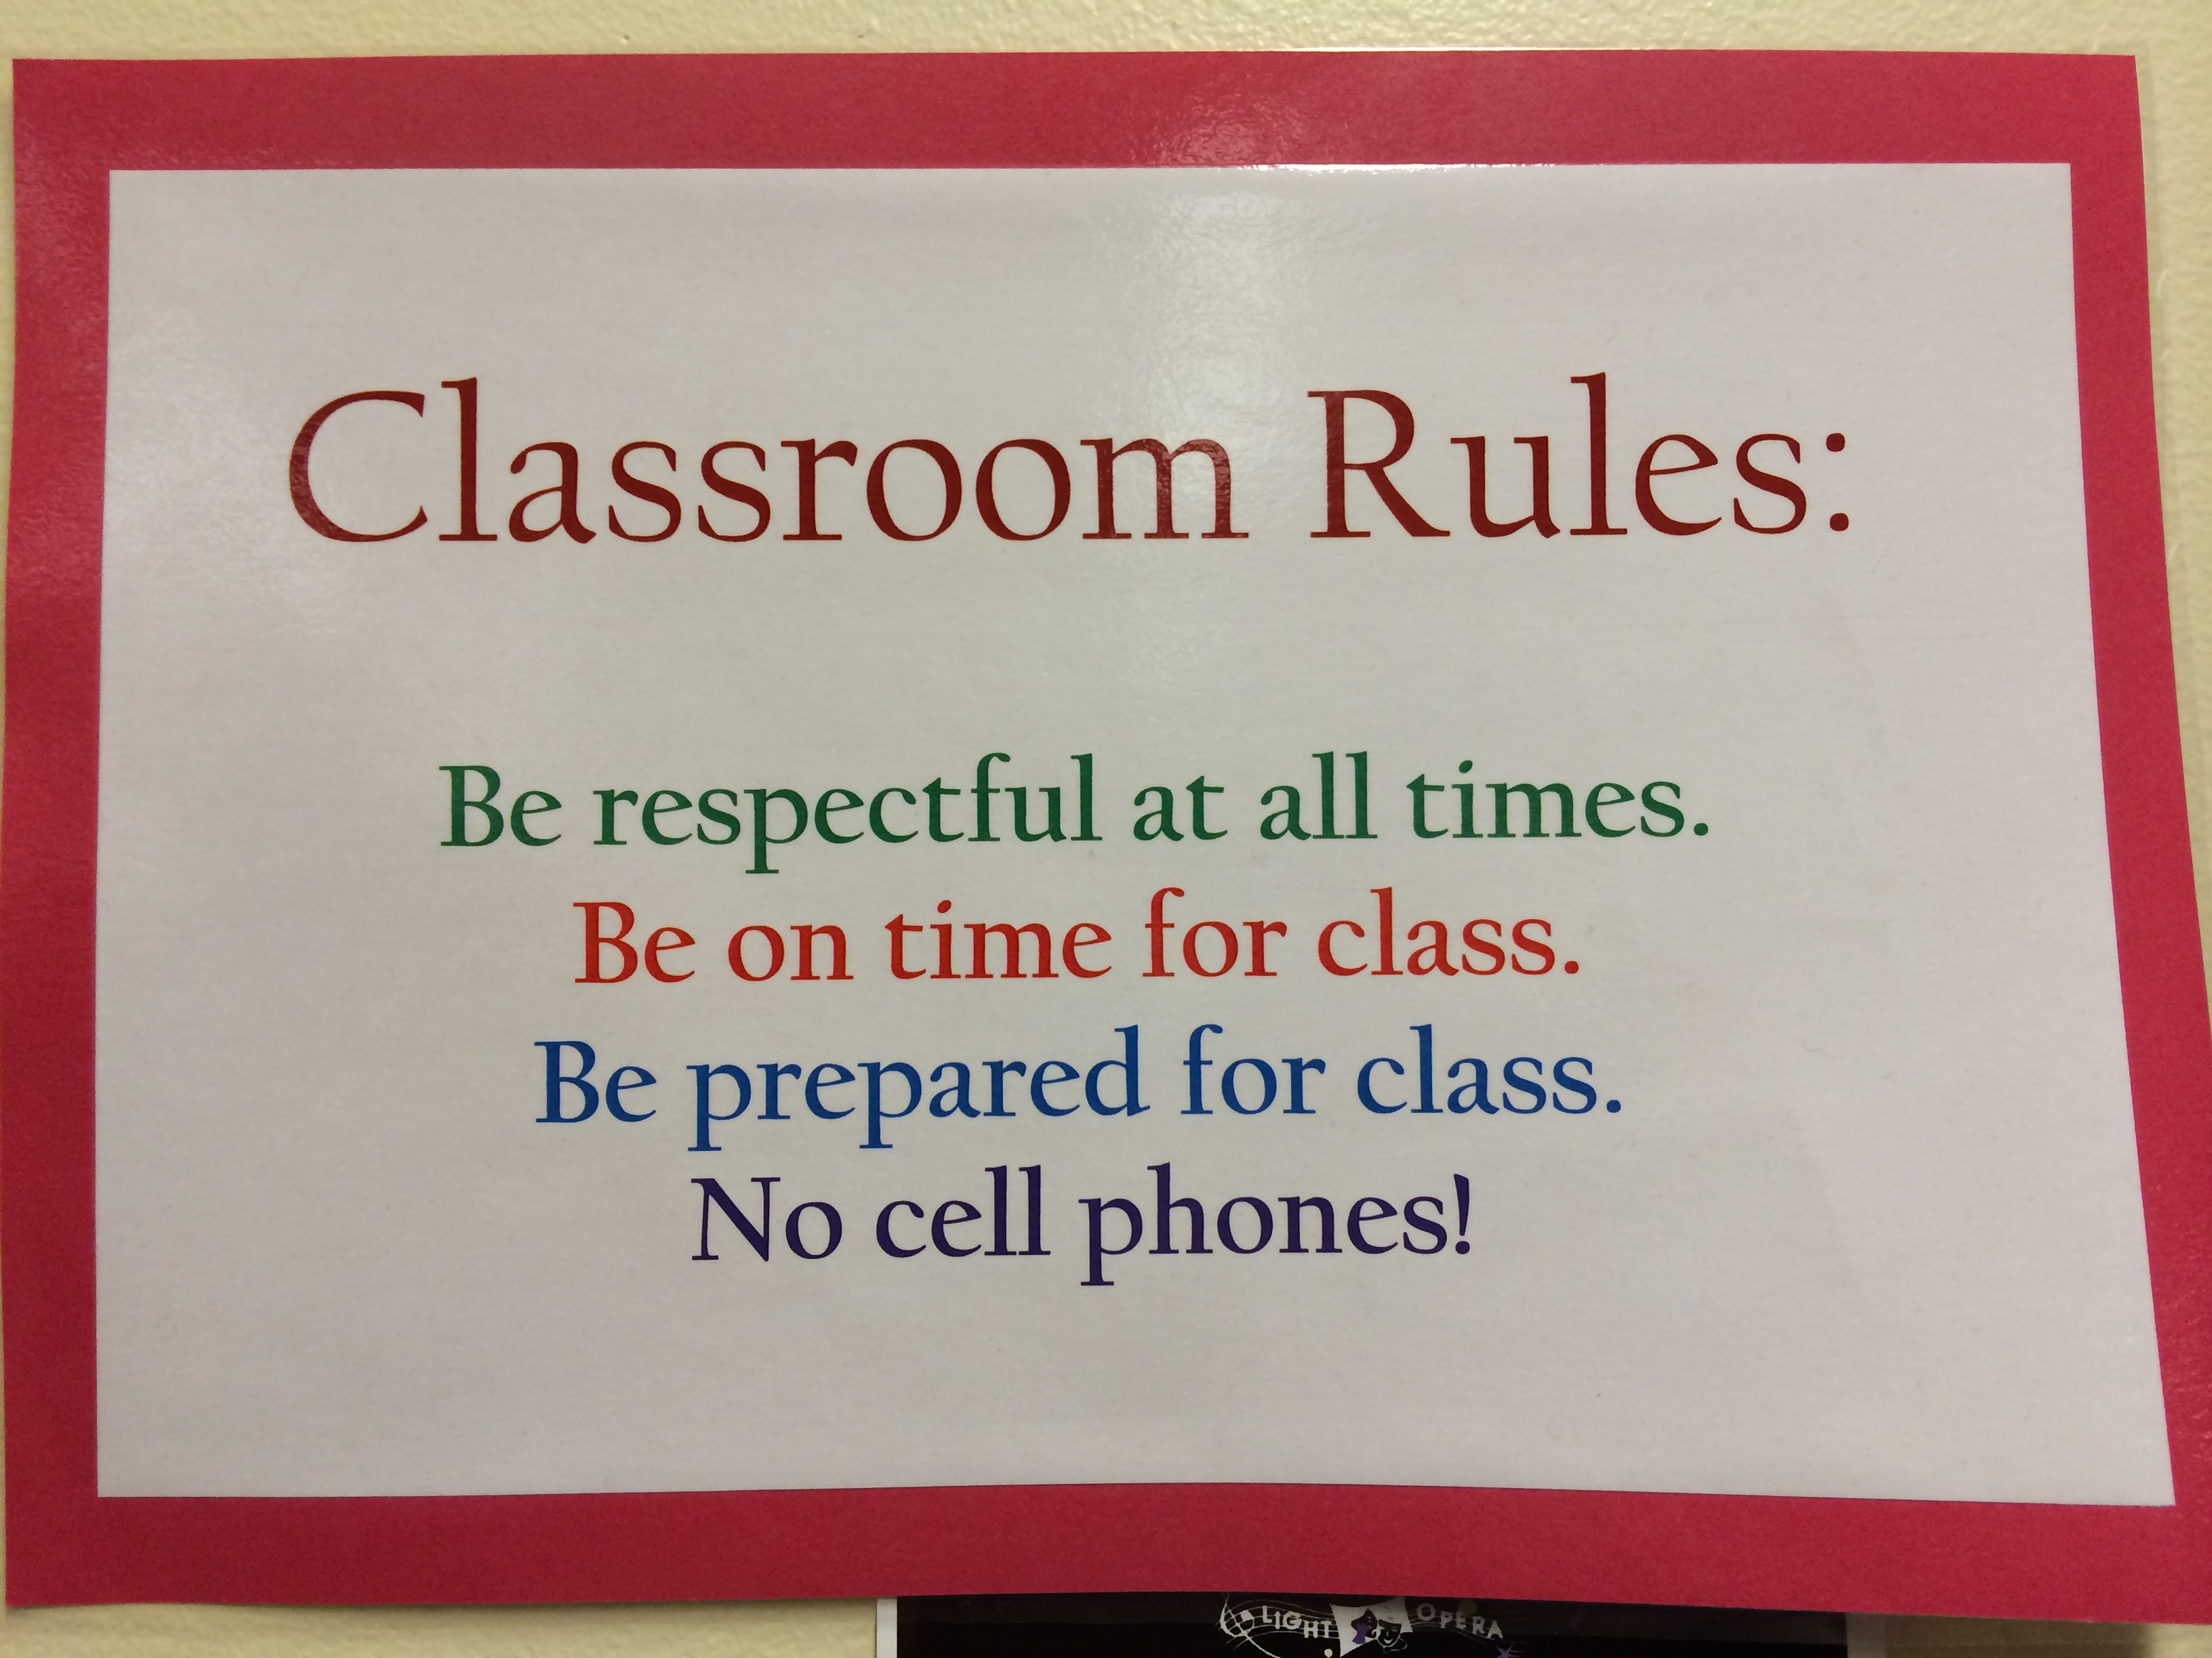
Policies /procedures/rules:
- The rules and procedures for my class will need to be established and enforced starting on day one in order for me to be an affective teacher and in control of my classroom, as is noted/suggested by Ryan Del Guercio in an official Journal of the New Jersey Education Association and later in a condensed article for the Education Digest.
Within my class following four simple basic rules will be implemented:
Be respectful at all times. This means that the students will need to be respectful to themselves, their classmates, the school staff, their assigned materials, and to their high school itself. They can exhibit being respectful in how they speak, listen, and act.
Be on time for class. Tardiness will not be tolerated! You will be sent to get a pass from the office (or another teacher) if you are tardy. No exceptions.
Be prepared for class. The students must bring their binder, paper, pencil, calculator and textbook to class each day. They must be ready to participate in class. Do their homework and be ready to learn! Think and work on topic.
No cell phones! There is no reason a student should have their cell phone or iPod/MP3 player in class. If I see it, I will take it! The first time this happens, I will keep it until the end of the day. After the first time, your parent or guardian will have to pick it up.

- Discipline and Consequences— In order to manage a classroom positively and create a learning atmosphere, one rule suggested in a top ten list for classroom management published in the Volume number 80, issue 4 of Clearing House, states one can be proactive in deterring the need for discipline and consequences by merely moving around the room and keeping your eyes moving. If this should not suffice then the following Consequences will be in place:
- Verbal Warning—Students will be given a very clear verbal warning if their behavior violates the classroom rules. As suggested by Marzano, et al, the student should receive positive discipline strategies and if that does not work then a negative strategy may need to be implemented as a result of the students chosen actions.
- Lunch Detention—If verbal warning(s) given are not enough to deter the student from behaviors that violate the classroom rules, then they will be assigned 2 lunch detentions. Lunch detentions are school wide and not serving detentions will result in school wide discipline.
- Office Referral—Should a verbal warning and lunch detention not deter the behaviors that are violating the classroom rules, or when the student’s safety, myself or another person’s is compromised, then the student will be referred to the office for disciplinary action.

Safety and legal requirements:
- Teacher-student relationships—I will make sure that I am available to my students before school, during lunch time and after school to provide any additional help as needed for the students to retain/gain knowledge of the concepts required of them to learn in the subject they have me for. This comes with ease since I do have high expectations for my students and am willing to put in as much time as the student is willing to put forth the effort, to ensure that they understand the material we are covering in class. It is stated very clearly in the book Classroom Management that Works, in order for a teacher to be an effective teacher they must establish a proper professional boundary between the teacher and student, we are there as a teacher/professional not as a friend. Although I find this statement a little off-putting at first, I then realized that it doesn’t mean that I cannot be friendly and supportive to my students, in a professional role/manner.
- Student responsibilities—Students will be provided a text by the highschool and they are responsible for the care and upkeep of these texts and they must be returned at the end of the year. The students will need to supply the following: Pencil/pen, Composition book, a three-ring binder 1” or thicker, loose-leaf paper, graph paper, calculator (scientific-may be provided but do not count on it-cellphone calculators are not acceptable), colored pencils-at least three different colors. Students are also responsible for maintaining their own Academic Honestly
- Management at your school level—one must be aware of the school rules and the district rules. At the start of the year and mid-semester teachers are provided with a copy of the student handbook and the rules that are required of the students are listed in these handbooks. The teacher is also required to go over these with their students and the students/parents must acknowledge the receipt and sign a paper noting that they have read and understand the rules/regulations within the handbook. This is a process that is repeated each and every year and as a teacher I should also read, understand the content held within the handbook and have it readily available for reference if needed throughout the school year.
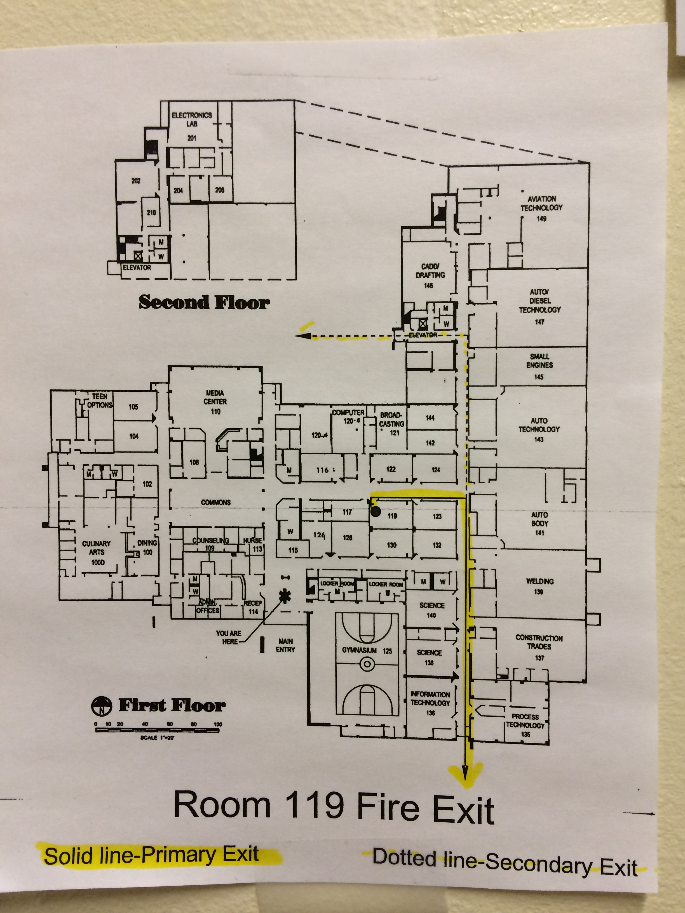
- Safety rules and procedures in place at your school/ school district—Throughout the year both my school and the district are required to employ fire-drills, safety drills, evacuation drills, lockdown drills, etc. As a teacher I should make sure that I have my copy of the flipchart/folder that has all of this information readily available and should re-read it throughout the year to keep it fresh in my mind. I need to make sure that I have the proper tools to help keep my students safe and warm during these drills and also should a real situation arise. By practicing and preparing my students ahead of time should the need arise we will be prepared as much as possible. The high school that I am student teaching in stores their information under the desk with an attendance slip, etc. to fill out and have for emergencies. The picture above is posted within the classroom by the door/exit and has the path we are to travel safely out of the building highlighted for easy review/ to refresh ones memory.

Student diversity:
- Special Needs students—In almost every class there are students who may be exceptional. In order to meet each student’s needs I must be aware of what these individual students needs are this oftentimes involves additional communication with the resource teacher at the school, the parents, and getting to know the students themselves. David Sousa the author of “How the Special Needs Brain Learns”, simply stated “ Learning is the process by which we acquire knowledge; memory is the process by which we retain it.(Sousa, p.13, 2007)” It is my responsibility to teach the mathematical concepts in different ways, so that I may reach the needs of all students who may learn through different avenues. By utilizing strategies that will aid visual learners (pictures, vocabulary, writing), oral learners, and auditory learners, or ESL learners all at the same time will make me a more effective teacher to more students.
- Cultural diversity (discussion, research)—by sharing my own diverse cultural background and opening up my classroom to all students and providing a positive environment for them to share their cultural backgrounds, it will help provide a more warm, welcoming environment for all the students in my class. By teaching students about the mathematical concepts through the use of their immediate surroundings, local elders, professionals, etc it can also help provide a place based learning environment that can allow all the students from many different cultural backgrounds to participate and learn the concepts without necessarily telling them how they apply the concepts.
- Working with Parents and Community—Over the past several years I have learned that in order for us as parents, tutors, or as teachers/educators, Communication with family, parents, and the community is essential in order to provide the type of educational support that is needed where we are working as professionals. I learned that by participating and helping to set-up, run activities that bring the community in to the schools to experience positive moments with their children and the community members alike, can only provide ourselves a win-win situation. If parents and the community are involved then the students will likely become more involved, the more the community is interested then the more support through donations, supplies, monetary supplements can come forth as well. Often times the community coming into the schools help the different clubs within the schools to earn money to support academic endeavors/activities that provide a welcoming environment for the students to participate in and grow intellectually and socially.

Planning and conduction Instruction:
- Mental Set (Section4)
- Diversity in Instruction—A way of diversifying my lesson when students do not get a concept with the use of a virtual manipulative the first time through working on a concept, I might then provide access to a solid three-D manipulative that they may physically hold in their hands and manually manipulate it.
- Student Motivation—Some students are motivated by grades, others by their peers, some by their parents, or others may be motivated by receiving verbal praise from their teacher. I often provide verbal praise to students when a student offers a solution out loud and engages positively during classroom discussion. I also tend to provide motivation by creating positive interactions with students, for example I have chaperoned a wrestling sporting event, while at the event I provided support to the students, and encouragement while wrestling. When we returned to the school I am able to make connections with those same students when I am teaching in the classroom, it provides me a topic to refer to the students would be interested in hearing about, and at the same time gives them recognition for their hard work and dedication outside of the classroom, while inside the classroom (recognize their placing in a recent tournament, during the beginning of class, etc.).
- Best practices in effective instruction and diversity in instruction. In the study of mathematics I was interested in learning how the use of a manipulative in order to increase student achievement was possible and if so how at the same time I might further engage my Algebra or Geometry students while implementing the use of technology in the classroom. Throughout my research there were plenty of scholarly Journals that described positive improvements in student learning or retention through the use of a manipulative during the teaching of mathematical processes or concepts. By the teacher utilizing and guiding the students through the use of a manipulative they can increase a students’ engagement and thus provide a deeper understanding of spacial awareness. One particular research project/report in a Journal by the authors Baki, A., Kosa, T., & Guven, B., wrote that student’s spacial awareness can be improved through the use of a virtual manipulative or a 3D- object manipulative( Baki, et al, 2011). I found that this would be an excellent new strategy for me to practice when teaching students mathematical concepts, especially those involving spacial awareness and visualizing abstract ideas. Below are some permalinks that I located that contain virtual manipulative sites:
- http://search.ebscohost.com.proxy.library.uaf.edu/login.aspx?direct=true&db=aph&AN=58509918&site=ehost-live
- http://search.ebscohost.com.proxy.library.uaf.edu/login.aspx?direct=true&db=aph&AN=32169416&site=ehost-live
- http://search.ebscohost.com.proxy.library.uaf.edu/login.aspx?direct=true&db=aph&AN=6774499&site=ehost-live
- http://search.ebscohost.com.proxy.library.uaf.edu/login.aspx?direct=true&db=aph&AN=15432872&site=ehost-live
- http://search.ebscohost.com.proxy.library.uaf.edu/login.aspx?direct=true&db=aph&AN=91548122&site=ehost-live

Summary:
In the process of researching and developing my own classroom management plan, it helped me to recognize the various levels of necessary planning in order to provide a caring, warm, learning environment that can and will help encourage students to embrace their abilities in learning mathematical concepts. There are many levels of management employed when guiding students on how to learn mathematics and through the process by which allows each individual to understand in the easiest process to them is or can be quite complicated for some while the process may be easy and simple for others. By learning that we all have our own strengths and weaknesses and by persevering through our weaknesses we can become even stronger learners and better mathematicians as a result of pushing through the times that we struggle.

Bibliography:

Alaska Department of Education and Early Development. (n.d.). In EED Alaska Content Standards. Retrieved December 1, 2013, from http://www.educ.state.ak.us/contentstandards/Technology.html.

Baki, A., Kosa, T., & Guven, B. (2011). A comparative study of the effects of using dynamic geometry software and physical manipulatives on the spatial visualisation skills of pre-service mathematics teachers. British Journal Of Educational Technology, 42(2), 291-310. doi:10.1111/j.1467- 8535.2009.01012.x.

Strategies for Effective Classroom Management in the Secondary

Setting. Clearing House, 80(4), 163-168.
Marzano, R. J., Gaddy, B. B., Foseid, M. C., Foseid, M. P., & Marzano, J. S. (2005). A handbook for classroom management that works (pp. 1-36). Alexandria, VA: Association for Supervision and Curriculum Development. Retrieved September 28, 2013.

Sousa, D. A. (2007). How the special needs brain learns (2nd ed., p. 13). Thousand Oaks, CA: Corwin Press.

Graphics/Photos:

The following are pictures taken inside of the current classroom that I am working in that is a high school setting for teaching the following subjects: Algebra I, Geometry, and Math in Health Care. The pictures include the set-up, arrangement of desks, technology available, and the management tools that are in place that provide for student academic responsibility and organization and procedure is in place for the collection and dissemination of student work.

The following photos are taken by Pamela L. Roehl, 2013

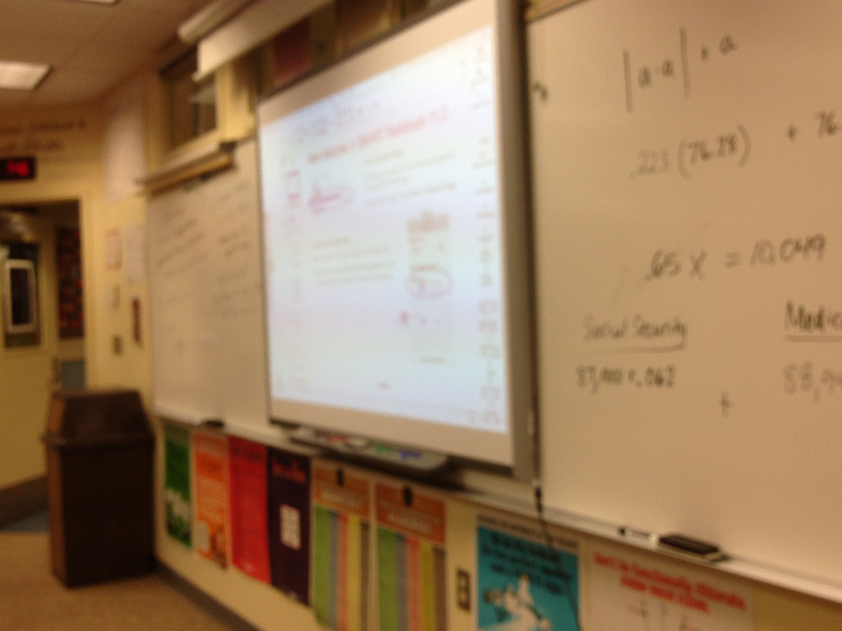
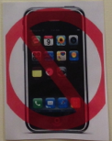
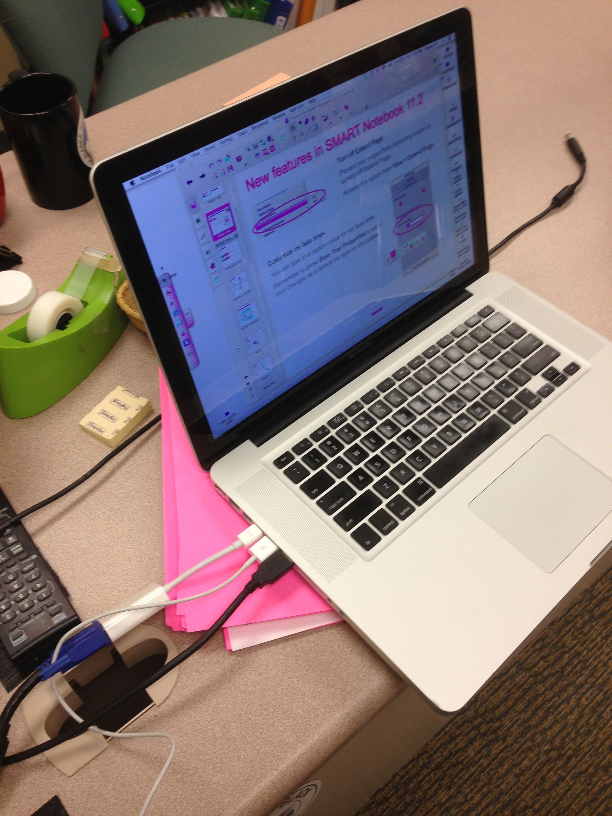

The Picture above is of a Smart Board and a white board being utilized in the teaching/instruction of mathematical skills and concepts.

My computer with Notebook Smart Board Software hooked up and ready to use for teaching lesson.
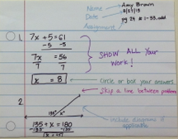
The picture to the left is an example that was created and posted for students to see a model of how to properly complete their homework assignments, inside of their composition notebooks.
